q-anth101

Norah Jones

2024-01-18

Table of contents

# Preface

This is a Quarto book.

To learn more about Quarto books visit <https://quarto.org/docs/books>.

# 1. Introduction

This is a book created from markdown and executable code.

See Knuth (1984) for additional discussion of literate programming.

|  |  |
| --- | --- |
|  | Note that there are five types of callouts, including: note, warning, important, tip, and caution. |

|  |  |
| --- | --- |
|  | **Tip with Title**  This is an example of a callout with a title. |

|  |  |
| --- | --- |
|  | **Expand To Learn About Collapse**  This is an example of a ‘folded’ caution callout that can be expanded by the user. You can use collapse="true" to collapse it by default or collapse="false" to make a collapsible callout that is expanded by default. |

|  |  |
| --- | --- |
|  | Note that there are five types of callouts, including: note, warning, important, tip, and caution. |

|  |  |
| --- | --- |
|  | Note that there are five types of callouts, including: note, warning, important, tip, and caution. |

|  |  |
| --- | --- |
|  | Note that there are five types of callouts, including: note, warning, important, tip, and caution. |

|  |  |
| --- | --- |
|  | Note that there are five types of callouts, including: note, warning, important, tip, and caution. |

# 2. Summary

In summary, this book has no content whatsoever.

# References

Knuth, Donald E. 1984. “Literate Programming.” *Comput. J.* 27 (2): 97–111. <https://doi.org/10.1093/comjnl/27.2.97>.

# 3. Understanding Culture



Decorative image of eight people of diverse nationalities with their arms around each others shoulders and waists. *Photo by fauxels on Pexels*

## Overview

***Welcome to ANTH 101!***

Anthropology is the study of all humans in all times in all places” (Wesch, 2017).

I have chosen two textbooks for this course. One that introduces you to a wide range of topics through a systematic, descriptive approach. However, you will notice that we do not cover all topics nor all chapters – there simply are too many. I have selected instead, the most common topics that will expose you to how contemporary people across the world live their lives differently than how you live yours. That textbook, called ***Perspectives,*** fittingly has numerous authors for the different chapters. However, I will refer to this resource as ***Perspectives*** rather than by the individual names of authors for each chapter.

The second textbook called ***The Art of Being Human*** is limited in scope and topics, but it takes you on a journey of discovery. The author, Michael Wesch, asks questions, and challenges you to find answers. He is masterful in working with core themes, which he presents as videos and challenges for you to do yourself. The New York Times recognized Wesch as an innovative teacher who “give(s) students an experience that might change how they think, what they care about or even how they live their lives” (p. 359).

Here are a couple of quotes that introduce you to the experience you are about to have through this course:

Anthropology is not only the science of human beings, but also the art of asking questions, making connections, and trying new things” (p. 5).

You will have to overcome your fears, step outside your comfort zone, and get comfortable with the uncomfortable” (p. 5).

… my willingness to change myself might be simultaneously the ONLY and BEST thing I can offer the world … “ (p. 353).

Wesch talks about being stretched himself – and he challenges you to be stretched – and become a healthy and responsible individual who can create a healthy and responsible society. If each of us does that, we collectively can create a healthier more inclusive and humane world. The fundamental experience of this textbook and the challenges through ***The Art of Being Human,*** is summarized this way:

“You cannot just think your way into a new way of living. You have to live your way into a new way of thinking” (p. 6).

### Topics

This unit is divided into the following topics:

1. What is Anthropology? What is Cultural Anthropology?
2. Anthropological Perspectives- Why is Anthropology Important?
3. What is Culture?

### Learning Outcomes

When you have completed this unit, you should be able to:

Define *culture* and the six characteristics of culture.

Discuss *ethnocentrism* and the role it played in early attempts to understand other cultures.

Explain how the perspectives of *holism*, *cultural* *relativism*, *comparison*, and *fieldwork*, as well as both *scientific* and *humanistic* tendencies make anthropology a unique discipline.

Evaluate the ways in which anthropology can be used to address current *social*, *political*, and *economic* issues.

### Activity Checklist

|  |  |
| --- | --- |
|  | Here is a checklist of learning activities you will benefit from in completing this unit. You may find it useful for planning your work. Learning Activities  1. Read and Reflect (20 minutes) 2. Watch the video… (8 minutes) 3. Explore the online resources… (10 minutes) 4. Read the Case Study… (10 minutes) 5. Take the ungraded quiz… (10 minutes) |

|  |  |
| --- | --- |
|  | **Assessments**  *Unit 1 Discussion Post*: Respond to the questions posted. *Unit 1 Quiz (5%)*: Assesses your understanding of Unit 1 learning outcomes. Refer to Chapter 1 of your textbook and other online resources. |

|  |  |
| --- | --- |
|  | **Tips for Instructors** Learning activities are typically ungraded, and can be optional for students, however they are designed to help students learn the material and prepare for the assignments. |

## 3.1 What is Anthropology?

We begin our study by introducing the discipline of anthropology. Anthropology is an attempt to systematically study and document cultural differences. This course is solely a study of one sub-field: cultural anthropology. We will not study the other sub-fields which are archaeology, biological anthropology and linguistic anthropology. All four sub-fields are “applied” meaning that applied anthropologists span the subfields and use anthropological methods, and findings to solve practical problems in public and private sectors such as business and health.

## 3.2 Anthropological Perspectives and Problem-Solving

Anthropology is unique from other social sciences, like psychology and sociology, in that anthropological perspectives involve four features:

* Holism
* Relativism
* Comparison
* Fieldwork

Because of its focus on differing and shifting perspectives, the study of anthropology enables students to think their way to another way of relating and living, and therefore “the anthropological perspective is an essential skill for nearly any career in today’s globalized world” (p. 17).

The *Perspectives* textbook introduces you briefly to the dual perspectives of anthropology being both scientific and humanistic (see p. 17). It is a science in its systematic approach. It is an art in that individuals are unique in their experience of their humanity. Michael Wesch, the author of your second textbook, shares “what the science of human beings can tell us about the art of being human.”

|  |  |
| --- | --- |
|  | ***Note*** *that the learning activities in this course are ungraded, unless specified. They are designed to help you succeed in your assessments in this course, so you are strongly encouraged to complete them.* |

### Resources

|  |  |
| --- | --- |
|  | The resources below will help you better understand the content explored in this unit. Take some time to explore this material; it will be discussed during the Learning Lab and will play an important role in course assessments. |

In order to build a foundational understanding of anthropology, it is important that we first understand why anthropology is important. The readings provided below are intended to guide your exploration of anthropology. When reading chapters in the textbooks, the chapters should be read in their entirety, unless you are instructed that you can omit certain sections. The entire articles have been provided for your reference but the instructions below outline important sections to focus your attention on.

### Activity Reading

|  |  |
| --- | --- |
|  | **Reading**  We begin with a reading that introduces the field of anthropology. Below is an outline of the reading that is to be followed in conjunction with the reading- it will help focus your attention:  **Outline**  Learning Objectives   * Four subfields of anthropology * Culture * Ethnocentrism * How anthropology is unique * Using anthropology to address current issues * What is anthropology?   + The study of …   + Four subfields     - …     - …     - …     - … * One practical subfield   + … * What is Cultural Anthropology?   + …   + …   + … * What is Culture?   + A set of …, …, and … that are …     - …     - …     - …   + Humans have the capacity …   + culture changes in response to …   + humans are not bound by culture but …   + culture is …   + our reliance on culture …   + … and … are interrelated * The (other) subfields of anthropology   + …     - …   + …     - …   + …     - …   + …     - … * Anthropological perspectives   + …     - based on     - … accounts of culture with …   + … vs … approaches     - biological subfield uses a …     - while the cultural subfield uses a … * Why is anthropology important?   + broad knowledge of …     - skills in … and …     - …     - …     - …   + The anthropological perspective undermines … and the idea that people are ….   After reading through the slides, take a moment to read the following section from the textbook - it will help support your understanding of the content presented above.  **Read** [**An Open Introduction to Anthropology**](assets/unit1/Introduction_to_Anthropology.pdf) |

|  |  |
| --- | --- |
|  | **Note:** *Read the introduction and be guided by the outline. Omit the brief history and sub-fields section. Read all other sections, including the “Applied Anthropology” section (pp 13-14) and “Why is anthropology important?” (p 17). Reading the illustrations of anthropologists at work is optional.*  **Note:** *Reading chapters from either of the two textbooks provides the foundation and content to the course topics. Understanding of this will be tested in 4 Unit tests.* |

### Activity Learning

|  |  |
| --- | --- |
|  | **Personal Reflection**  To build upon the first reading, this article offers additional context around the importance of anthropology: Read: [**Art of Being Human- Introduction**](assets/unit1/ArtOfBeingHuman2017Intro.pdf)Reflect *After reading the article, complete the following:*  Take a few moments to read through the chapter; towards the end of the letter to students you will find a section titled **“Ten Big Ideas.”** Take some time to carefully read through this section again- identify which of those “big ideas” are particularly significant (from your perspective).  Next, consider the following quote:  **We fail to examine our assumptions**.  While many of us may not think that *“we are the center of the universe,”* this Learning Activity provides an opportunity to reflect on some of our own assumptions. For this reflection, consider the following guiding questions:   1. How much of your daily routine, thoughts and habits focus on YOU? 2. What do you think about (daily)? 3. What do I do that is all about ME?   *Be prepared to share your thoughts with the rest of class during the Learning Lab.* |

## 3.3 What is Culture?

Several sources will be used to learn and reinforce the fundamental ideas about culture. This section has several important terms and concepts. You will learn about the characteristics of culture and also learn about cultural universals versus cultural relativism, and about ethnocentrism which influences how you see yourself and others.

We will cycle through the ideas of Culture with three rounds. First an introductory exposure to the study of culture, then aim to gain perspective through a classic article about Americans and a modern perspective on a Western pastime, golf. The third round of readings and embedded videos will revisit some concepts you’ve already been introduced to, and add important new ideas. The material covered in this unit provides the fundamental concepts, and therefore, we will cycle through some terms or concepts more than once.

|  |  |
| --- | --- |
|  | **Critical Thinking Question**  *Why is ethnocentrism the major obstacle to the understanding of other cultures? How might it be overcome?* |

### Resources

The resources below will help you better understand the content explored in this unit. Take some time to explore this material- it will be discussed during the Learning Lab and will play an important role in course assessments.

### Learning Activity

|  |  |
| --- | --- |
|  | We begin this section by reading Lesson Two from Wesch’s text. This reading is intended to help us better understand what culture is. Click on the links below - **Read**  * [**The Art of Seeing**](assets/unit1/Art_Of_Seeing.pdf) * [**Body Ritual among the Nacirema**](assets/unit1/Body_Ritual_Article.pdf) * [**Growing Up Among The Nacirema**](assets/unit1/growing-up-among-the-nacirema.pdf)  Watch and Reflect Take a moment to watch the following video and consider how some of the themes explored in this unit and the readings connect to subject of this video. **Watch** [Adventures with the Nacirema]*Reading* Read the following article. As you read the article, it is suggested to follow along with and complete the outline provided which will help you better prepare for assessments in the course.   * **Read** [**Perspectives- Chapter 13**](assets/unit1/u1_perspective-chapter13.pdf)   ***To support your learning, please copy and paste the outline below into your own note-taking app and write while you read.***  The Development of Anthropological Ideas Outline   * Questions * How did cultural anthropology concepts define the discipline? * How does the anthropological perspective differ from other prespectives? * What is the relationship between colonialism and anthropology? * How do specializations reflect the range of questions that anthropologists address? * Central Concepts * Culture   + Tylor …   + Morgan … * Holism   + taking a broad view …   + Boas … * Plasticity   + Boas … * Participant Observation   + Malinowski … * Area studies and beyond   + …   Read the following article. As you read the article, it is suggested to follow along with the slides provided- they will help you better prepare for assessments in the course.   * **Read** [**Perspectives- Chapter 2**](assets/unit1/Perspectives-ch2.pdf)   ***To support your learning, please copy and paste the outline below into your own note-taking app and write while you read.***  The Culture Concept Outline   * Main Topics * Ethnocentrism and cultural relativism * Early anthropologists Frazer and Tylor * armchair anthropology vs. participant-observer fieldwork * Franz Boas and culture * Ethics * Thoughts on culture over a cup of coffee * How do you define culture? * anthropologists developed the culture concept * Importance of … * How anthropology became a … * Stories as a reflection of culture * *The Other* … * *Gulliver’s Travels* … * Armchair anthropology … * Ethnocentrism … * Early explorations and … created ideas of … * Sir James Frazer- *The Golden Bough* (1890)   + … * Sir EB Tylor- *Primitive Culture* (1871)   + …   + …   + human groups go through stages of …, …, and … * the 20th century brought … to anthropology and the importance of …   + …   + Bronislaw Malinowski … * The development of the theories of culture * Anthropology in Europe   + Functionalism     - …   + Structural-functionalism     - …   + However, these theories do not explain … * Anthropology in the US   + Franz Boas * Cultural relativism … * Benedict, Mead, and Kroeber   + … * Ethical issues in truth telling * American Anthropological Association Code of Ethics   + … * Malinowski in the Trobriand Islands   + …   + … * Chagnon and Neel in the Amazon of Brazil and Venezuela   + …   At this point, you will revisit some ideas you have learned about, and also add a few more new concepts to your understanding of culture.   * **Read** [**Understanding Culture**](https://humangeography.pressbooks.com/chapter/understanding-culture/) from the beginning, and finish just before the section titled *“Culture Change.”*”   The chapter includes a video on *Symbols, Values, and Norms*, and a second one on *Cultures, Sub-Cultures and Counter-Culture*. End at that point. You do not need to read the *Cultural Change* section we will pick that idea up at the very end of the course.   * **Read** [**Understanding Culture**](https://humangeography.pressbooks.com/chapter/understanding-culture/) |

### Learning Lab Information

Welcome to the first Learning Lab of the course. Each week, it is expected that students attend, and actively engage in a Learning Lab. For this course, the structure and expectations of this time will vary. During this time, however, students will be engaging with their Instructor and/or their Facilitator- they will be leading the session and providing guidance. Additionally this time provides an opportunity for students to seek support or ask questions about any of the elements of the course.

It is expected that students preview the **Learning Lab** section of each unit ***prior*** to attending this session. Often their are readings or activities that you will need to complete in order to prepare for this component of the course. It is also important to note any guiding questions from the Learning Activities embedded throughout each topic- your Facilitator will also be using this time to review the themes from these activities. It is important to review each so that you are prepared to engage with the rest of the group.

{–For most Learning Lab sessions, students will earn marks towards their “Participation” grade for the course. However, some of the Learning Labs will require students to formally present their ideas and research- this will count towards the “Activities” component of your final grade.–}

Be sure to carefully read through the instructions for the Learning Lab each week and organize your time accordingly.

### Learning Lab: Talking to Strangers

We begin our first Learning Lab with a challenge: talking to strangers! As you have learned in this unit, anthropology involves exploring the lives and cultures of others. Based on that exploration, we can develop an understanding of how people live and what things make them unique.

***To begin this activity,*** follow the link below. Here you will find instructions for this challenge.

[**Talking to Strangers**](https://anth101.com/challenge1/)

Once you have completed the challenge, you will be asked to share your experience. Use the guidelines provided on the link to prepare your thoughts.

During the set time for the Unit 1 Learning Lab, students will be expected to share their thoughts and ideas from their experience during this *challenge.* Your Facilitator will be guiding the conversation but will be expecting each of you to engage and contribute to the conversation.

As noted above, some time during this Learning Lab will also be set aside so that you can ask any questions you have about the course. Your Facilitator will also be taking some time to review some general information and expectations for the course.

In addition to the activity above, each student should be prepared to discuss the readings and activities found throughout Unit 1. The Instructor and/or Facilitator will be using the Learning Lab to explore these resources.

|  |  |
| --- | --- |
|  | **Note:** *Students will be assessed, during Learning Labs, based on the* ***“Participation”*** *criteria. This criteria can be found under the* **Assignment** *tab at the top of the page. It is important to review this information prior to the Learning Lab.* |

## Summary

[add content]

//todo #1

## Assessment

|  |  |
| --- | --- |
|  | Students are not responsible for submitting any assignments for grading in Unit 1. Please note, however, that **the content of Unit 1 will be assessed as part of the test you will take at the end of Unit 2.** It is strongly recommended that students review the content from Unit 1 to prepare for this assessment. One way to do that is to use the blank outlines provided on this page and try to reproduce the full outline without looking at your notes or the readings. Once you have finished that, then compare to your completed notes and the readings to will see what you need to review. Repeat this process before your exam, and/or as many times as you need to. |

## Checking your Learning

|  |  |
| --- | --- |
|  | Now that you have completed the learning activities and assignments for this unit, check the unit learning outcomes below to see if you are able to do the following:   * Define *culture* and the six characteristics of culture. * Discuss *ethnocentrism* and the role it played in early attempts to understand other cultures. * Explain how the perspectives of *holism*, *cultural relativism*, *comparison*, and *fieldwork*, as well as both *scientific* and *humanistic* tendencies make anthropology a unique discipline. * Evaluate the ways in which anthropology can be used to address current *social*, *political*, and *economic* issues.   Feel free to review topics more in depth or continue on to the next unit. |

# 4. Fieldwork

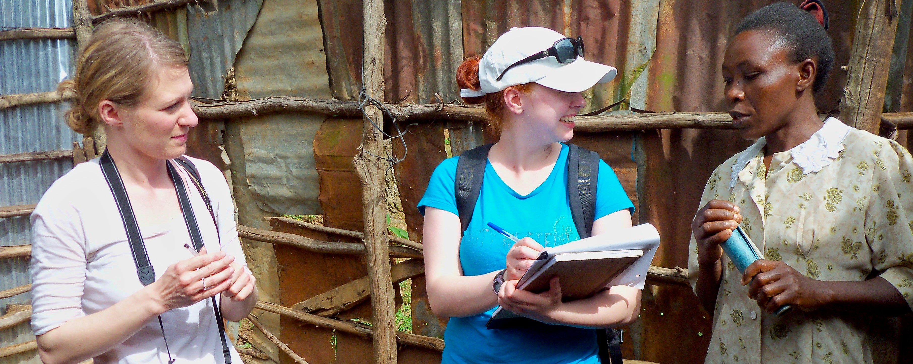

*TWU travel study students interview a Kenyan villager. Photo by Ruth Anaya*

## 4.1 Overview

In Unit 1, we began our exploration of Anthropology by introducing the field and, in particular, developing an awareness of the importance of culture. Unit 2 will continue to build on your understanding of culture by focusing on how to do research in Cultural Anthropology and that involves: *Talking to strangers!*

For any of you who have been in a situation where you meet someone new *(a stranger)*, you will know how challenging it can be to establish rapport - typically this is done with “small talk” (also known as relationship building). As an Anthropologist, we might (or might not) be interested in relationship-building, but this vital step is critical for something we are VERY interested in: ***discovering answers to BIG questions.*** Without the ability, and skills, to build rapport with strangers, it is very difficult to get a relationship to a place where we can ask the bigger questions we really seek answers to. It is important to remember then, that the more you connect with others, that is, deeply connect with others, the more you will discover the differences that *“represent [a] vast range of human potential and possibility” (Wesch, p. 27).*

This unit will prepare you to start exploring the world….

### Topics

This unit is divided into the following topics:

1. Perception
2. Fieldwork (Methods)
3. Fieldwork (Practice)
4. Implications of Fieldwork

### Learning Outcomes

When you have completed this unit, you should be able to:

* Demonstrate how to go about doing an ethnography
* Describe how ethnographic fieldwork differs from other approaches
* Explain contemporary ethnographic fieldwork techniques and perspectives, including the difference between cultural and cross-cultural research methods
* Identify and list ethical considerations in fieldwork
* Explain the difference between individualism and collectivism

### Activity Checklist

Here is a checklist of learning activities you will benefit from in completing this unit. You may find it useful for planning your work. Note that all Learning Lab activities contribute towards your Participation mark for this course.

|  |  |
| --- | --- |
|  | Learning Activity 2.1 At the end of Topic 1, students will find Learning Activity 2.1. For this activity, students will be exploring a resources that will challenge your “views” of the world around you. Carefully consider your experience as you engage in this activity. You will be asked to share your thoughts as part of the Learning Lab for Unit 2. |

### Topic 2 Resource

At the bottom of the page in Topic 2, students will find some important resources. It is expected that each student read through the slides and the articles. It is important to note that this content will be assessed and will help support your learning throughout the course.

## Learning Lab

During this Learning Lab, students will be presenting their photos from the **Ethnography Challenge.** Refer to the information found on the “Assessment” tab as it will provide direction as to what is expected as part of this presentation. **Be sure to arrive to the Learning Lab prepared to present your photos!!!**

### Assessment

|  |  |
| --- | --- |
|  | Each student is expected to submit their first assignment for the course: the “Ethnography Challenge - Activity #1.” Carefully read through the instructions - your completed assignment can be submitted to the dropbox found at the bottom of the page. **Please also note that there is a presentation component to this assignment as well. This will be part of the Learning Lab for Unit 2**. Finally, each student will need to complete their first Unit Test at the end of Unit 2. This test will cover content from Units 1 and 2. The link, and additional information, can be found on the “Unit Test #1” link at the bottom of the page. Your Facilitator will provide additional direction and support for any questions you may have. |

### Resources

* Biswas-Diener, R. & Thin, N. (2020). Culture. In R. Biswas-Diener & E. Diener (Eds), *Noba textbook series: Psychology.* DEF Publishers. <http://noba.to/y9xcptqw>
* Brown, N., de González, L. T., McIlwraith, T. F., & American Anthropological Association. (2018). *Perspectives: An Open Invitation to Cultural Anthropology.* <http://perspectives.americananthro.org/Chapters/Introduction_to_Anthropology.pdf>
* Wesch, M. (2018). *The Art of Being Human: A Textbook for Cultural Anthropology.* New Prairie Press. <https://anth101.com/wp-content/uploads/2018/01/ArtOfBeingHuman2017Intro.pdf>
* Other online resources will be provided in the unit.

## 4.2 Perception – *How You See and Experience Culture*

Our first topic of Unit 2 reinforces, and expands, our understanding of culture. We will begin with the topic of perception: *how we see.*

In Unit 1, you were introduced to the works of Wesch in his quest for answers to important questions. Throughout the course I will often refer to his words as he articulately captures some of the big ideas we are exploring in this course. In this unit, we will introduce some more of his thoughts in his approach to fieldwork. Wesch says:

*We can respond to human differences with hate or ignorance, or we can choose to open up to them and ask questions we have never considered before.*

|  |  |
| --- | --- |
|  | **Learning Activity**   * Our exploration of fieldwork requires developing our skill of awareness. To begin, turn your attention to:   [**Asking Questions, Making Connections, and Trying New Things**](https://twu-fhss.github.io/anth101book/fieldwork.html) |

|  |  |
| --- | --- |
|  | ***Note:*** *Although you are directed to a specific page,* [*please feel free to explore the rest of the site*](https://anth101.com/) *as it can offer many resources, and challenges, to help support your learning.*  Here, we learn about the *Art of Seeing:*   * ***Seeing our own Seeing*** to work past our assumptions. * ***Seeing Big*** using complex models of culture. * ***Seeing Small*** and noticing how the little things matter   And putting it all together to ***“See it all”*** using the holistic perspective. |

## 4.3 Fieldwork – *How to Study Culture*

We now turn our focus to read about other’s experiences in their endeavors to learn about others. Once again, our study will turn to Nacirema as we learn how traditional approaches differ from the approaches we use today. While anthropologists make choices as to the techniques they use, they are duty-bound to give ethical consideration to every study. A fundamental guideline for all Anthropologists is ***“Do no Harm.”***

Below, you will explore culture through two activities. One activity will be **etic:** *you as an observer;* the other activity will be **emic:** *you as a participant.*

### Resources

The resources below will help you better understand the content explored in this unit. Take some time to explore this material - it will be discussed during the Learning Lab and will play an important role in course assessments.

### Activity: Reading

|  |  |
| --- | --- |
|  | ***Reading #1***  We now turn our attention to expanding our understanding of culture. We begin by following the link below:   * [**NOBA - Culture**](https://nobaproject.com/modules/culture#content)   Pay special attention to the “Social Psychology Research Methods” section, and note the difference between ***ethnographic study*** and ***cross-cultural research methods*** (Table 1).  Also, take a moment to reflect on how self is understood (situational identity) and valued differently in individualist and collectivistic cultures (Table 3). I also invite you to take a few moments to consider how cultural relativism and ethnocentrism lead us to value self and others differently (*cultural intelligence*). *Reading #2* Next, we turn our attention to reinforcing our understanding of fieldwork. Below is an outline that should be followed in conjunction with the reading. Please copy and paste the outline into your notes and complete them as you read.  Click to Open  Learning Objectives   * doing ethnography * how ethnographic fieldwork contrasts with other approaches * contemporary ethnographic fieldwork techniques and perspectives * ethical considerations * how do data become a story with meaning   Finding the Field   * Fieldwork   + the most important method by which …   + Chapter author Katie Nelson conducted fieldwork … * … by Mead (1925) * … by Miner (1956) * Ethnography -the in-depth study …   + “t… d…” * Participant Observation   + … * … (insider) and … (outsider) perspectives   Traditional Ethnographic Approaches   * “Armchair” Anthropology   + … * Bronislaw Malinowski, … (1922) pioneered the … * Salvage ethnography   + sought to …   + Flaherty’s film … (1922)   + Catlin and Curtis curated …, creating the image of … * Holism   + integrating … * In anthropology in the United States, this resulted in the … Approach: …, …, …, and … anthropology   + Emphasized links between fields, such as … (… hypothesis)   Ethnography Today   * Ethnography may be conducted … * Using a … approach * Q… vs. Q… * … are used more often today   Ethnographic Techniques and Perspectives   * Cultural relativism   + the idea that … * Ethnocentrism   + the tendency to … * … anthropology strives to …, not only research their practices objectively * … and … anthropology believes there is no …, and that culture is … * Participant observation   + Develops … with informants * Conversations and Interviews * Life histories * Genealogy * Key informants * Field notes   Ethical Considerations   * …’s Code of Ethics   + Stresses … of study participants and …   Writing Ethnography   * Data analysis * Challenging the old idea of “…” * Poly… * …   In addition to the outline above, read through the following chapter which will help support your understanding of the ideas and themes identified in the outline above:  [**An Open Introduction to Anthropology**](https://pressbooks.pub/perspectives/chapter/doing-fieldwork-methods-in-cultural-anthropology/)  *Pay special attention to the section on “Ethical Considerations,” and reflect on the principle of “Do no harm.”* |

## Learning Lab

As part of your Learning Lab, you will also present your **Ethnography Challenge** assignment. This assignment can be found by selecting the “Assessment” tab for Unit 2.

As we come to the end the end of Unit 2, your facilitator will help organize groups for this unit’s Learning Lab. Once you have joined a group, your task is to select, and discuss, ONE of the following questions about culture change. *Please note, you will be asked to share your thoughts with the rest of the group at the end.*

1. ***Ethnotourism*** (people travelling to visit and experience Indigenous cultures and societies) is becoming more popular. While it offers economic opportunities, it is also changing these cultures. How might a small-scale culture be affected, and how might an anthropologist work with them to adjust to changes brought about by tourism?
2. ***Dishwashers*** are not common in Japanese homes. If you were tasked with marketing dishwashers in Japan how would conduct the research?
3. How might the introduction of ***computers*** in a small-scale society change people’s ideas attitudes and behaviours?
4. If you were working with an Indigenous people in rural India to improve ***irrigation,*** what questions would you ask?

|  |  |
| --- | --- |
|  | **Note:** *Students will be assessed during Learning Labs based on the* ***“Participation”*** *criteria. This criteria can be found under the* **Assignment** *tab at the top of the page - it is important to review this information prior to the Learning Lab.* |

### ***Looking Ahead…***

Although your Facilitator will mention this to you, please take some time to look ahead to Unit 5 as you will have a major assessment involving a Case Study. While it might be premature to begin that assignment now, *it is certainly a good time to start thinking about it.*

Below are a few resources to help with this process. For now, the goal is to expose you to two similar yet different indigenous cultures: the **Maori** of New Zealand, and the **Aborigines** of Australia.

As you watch this videos, be observant! I would encourage you to watch these short clips several times to capture the details of the environment, the things that are said (*and how they are said*), and relationships – self to the physical world, the social world, and the spiritual world.

## Assessment

|  |  |
| --- | --- |
|  | Students are responsible for two graded assessments during this unit. The first assignment, the **Ethnography Challenge - Activity #1,** is outlined below - this assignment will be presented as part of this unit’s Learning Lab.  Additionally, students are responsible for taking **Unit Test #1.** This test will assess your understanding of content from Units 1 & 2. |

### Ethnography Challenge - Activity #1

Unit 2 presents your first formal assessment. This will involve participating in an activity that focuses on ethnography. Your task, for this *Challenge,* will be to gather your own cultural material in the form of pictures or videos so that they can be used for interpretation - by you and others!

|  |  |
| --- | --- |
|  | ***Please Note:*** *Part of this assignment (the Discussion) will be shared during your Learning Lab!* |

#### ***To Begin***

Below, you will find a link that outlines this *Challenge.* Take a moment to carefully read through the instructions. Additionally, you will also find some examples of what materials could look like.

Click on the link below to begin:

[**Fieldwork of the Familiar**](https://anth101.com/challenge2/)

|  |  |
| --- | --- |
|  | **Important** *We will not be expecting students to post their pictures on Instagram (or any other social media platform). Instead, this step is to prepare for our Learning Lab where you will be sharing your pictures with the group so that we can respect everyone’s privacy from the public - these materials will, however be uploaded to the assignment dropbox found at the bottom of this page.* |

#### ***Next…***

Now that you have read through an outline of this activity, it is expected that each student will bring four or five photos to share with class - ***these will be shared during the Learning Lab for Unit 2.***

***TIP for sharing your photos*** - Do not distort your picture if you paste it to a PPT slide or a Word document. You may crop a picture but you should not stretch it in any one direction. It should always look as it was when you took the picture. In MS Word or PPT, you can select ‘Lock Aspect Ratio’ when resizing.

By this point in the course, you have learned how important detail is to an Anthropologist - for this reason, it is important that you are ***very, very descriptive.*** As part of your presentation, each student must create a list of at least **20 descriptive words or phrases** that describe elements/components of your photos - these will be shared with the class.

As part of developing these descriptions, consider the following guiding questions:

1. Is there a prominent use of a particular color or colors?
2. Does quantity or size appear to be emphasized?
3. Is there a lot of variety within one domain (an area of focus)?
4. Are things simple or complex and detailed?
5. Do you see conformity in behaviors? What things appear to be the same? What is everyone doing, or wearing, etc…?

#### ***Finally…***

Following the Learning Lab, it is expected that you will upload your ***favorite*** photo to the dropbox provided (i.e their *one* favorite photo).

As part of this submission, students **MUST include a caption.** Again, consider how important descriptive language is to an anthropologist - get creative!

Once this step has been completed, upload your photo and caption to the **Ethnography Challenge - Activity #1** dropbox.

Here are the grading criteria that will be used to assess your submission:

|  | Assessment Criteria | **%** |
| --- | --- | --- |
| **Meaningfulness** | Evidence of meaningful thought put into searching out, and seeing the “unfamiliar.” | 1 |
| **Quality of Data** | The picture is meaningful in the sense that it was chosen to document cultural features in a meaningful manner that is intentional in its focus of the subject matter. | 1 |
| **Creativity of Images** | Image composition demonstrates creativity in some form (e.g. use of light, color, perspective, etc…) | 1 |
| **Discussion** | Your oral description of your pictures should be accurate, rich and vivid. Also, clearly explain your field experience. | 1 |

*This activity will represent 4% of your overall grade for the course - your Facilitator will be grading this assessment*

## 4.4 Unit Test #1

In addition to the Ethnography Challenge, each student is required to complete the first unit test at the end of Unit 2.

|  |  |
| --- | --- |
|  | ***Please note*** that this unit test will focus on all content covered in Units 1 & 2. Be sure to take some time to review the content in each section.  Additional information can be found by selecting the **Unit Test #1** tab at the bottom of the page. Here, you will find instructions for taking the test.  *This test will represent 10% of your overall grade for the course.* |

## Checking your Learning

|  |  |
| --- | --- |
|  | Before you move on to the next unit, check that you are able to:   * Demonstrate how to go about doing an ethnography * Describe how ethnographic fieldwork differs from other approaches * Explain contemporary ethnographic fieldwork techniques and perspectives, including the difference between cultural and cross-cultural research methods * Identify and list ethical considerations in fieldwork * Explain the difference between individualism and collectivism |

# 5. Understanding Livelihoods (Subsistence and Economics)

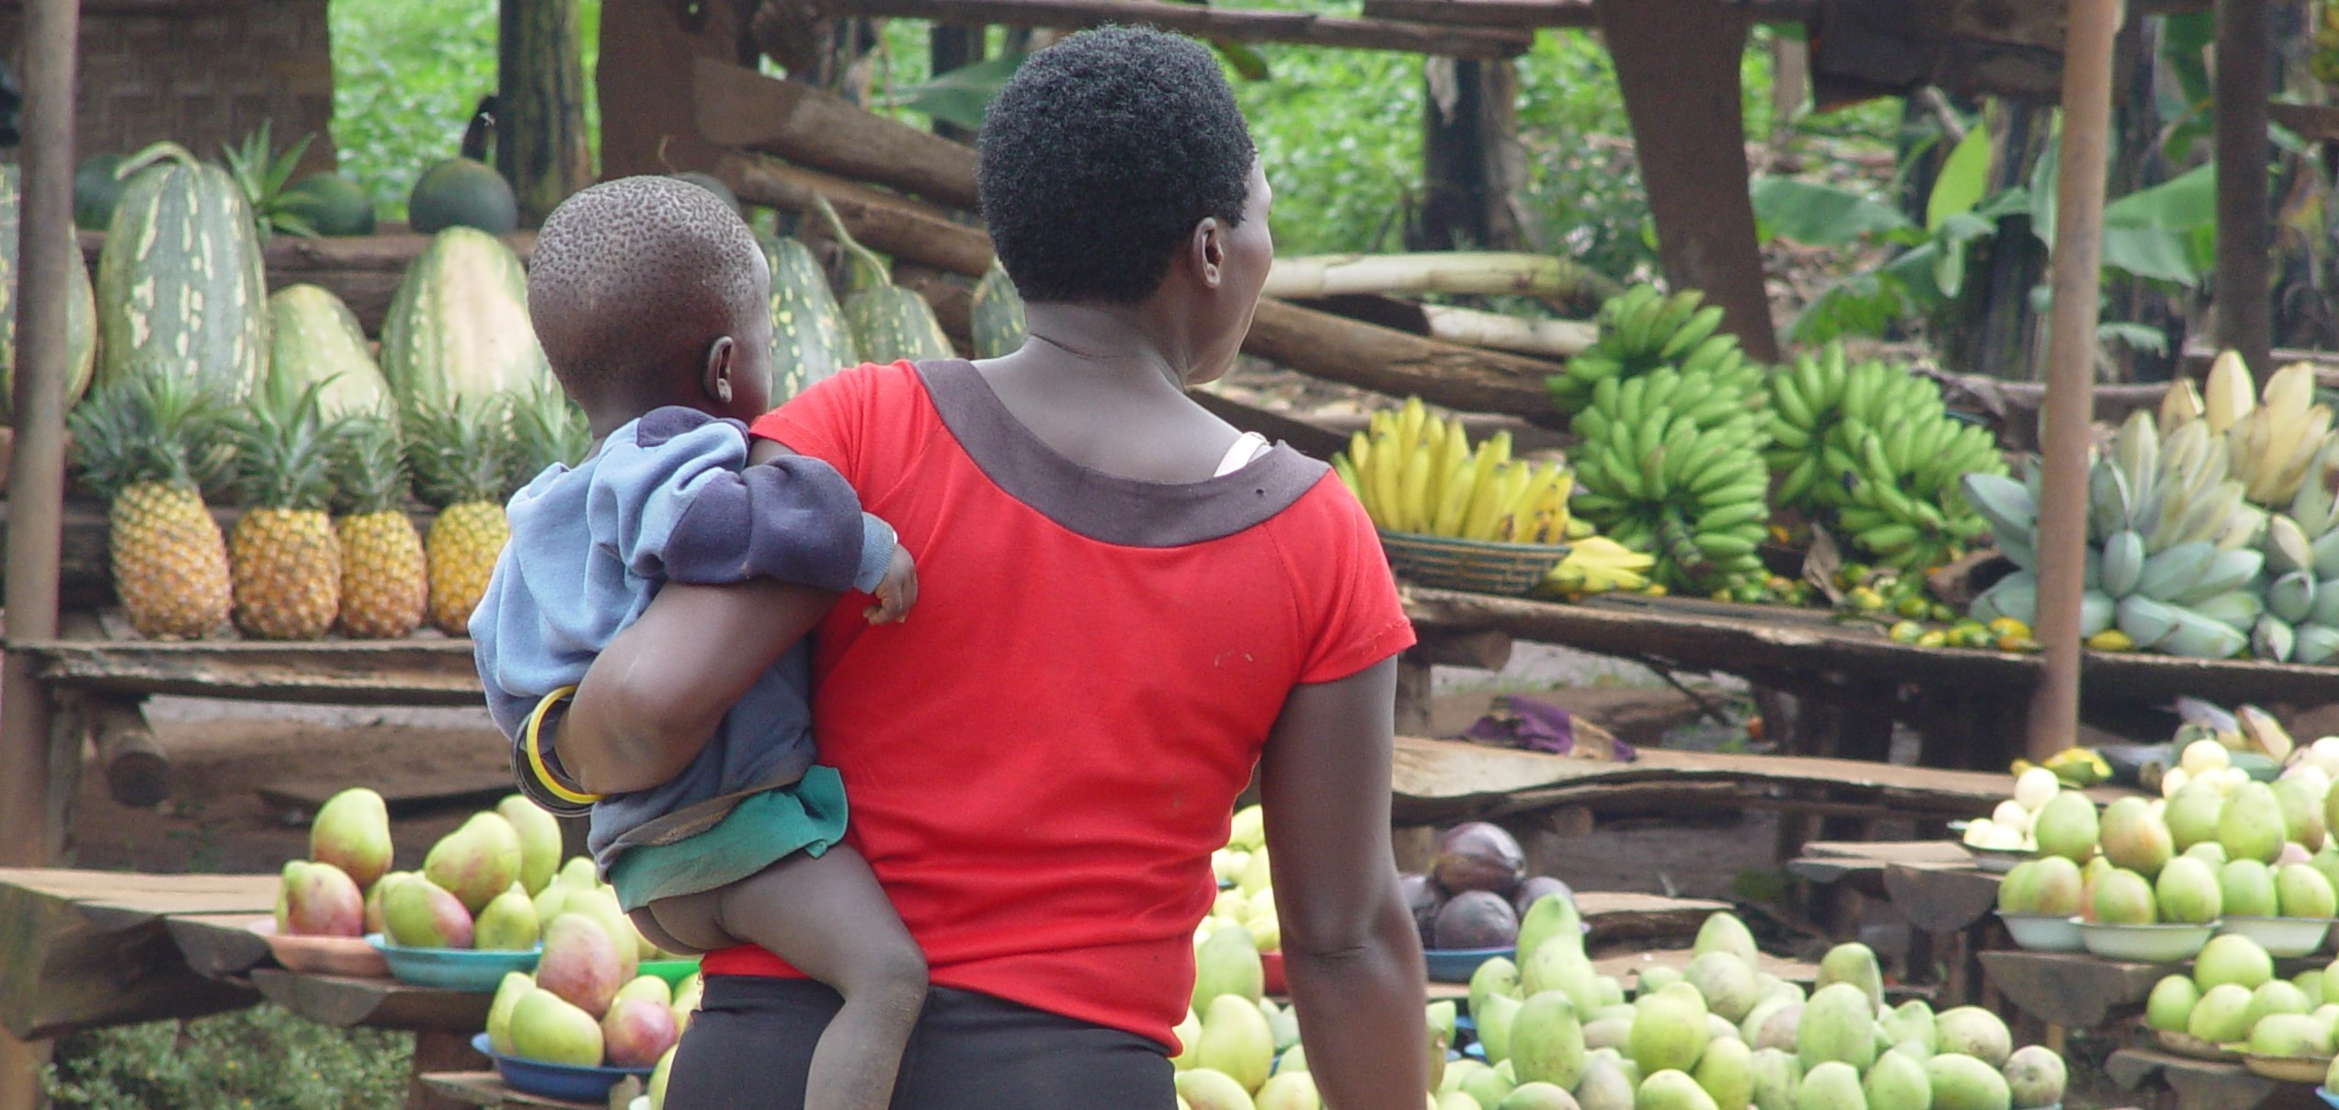

*Market Day in a town in Uganda. Photo by Ruth Anaya*

## Overview

In Unit 3, we will shift our focus to learning about the many different ways in which societies lived across the span of history, and how they live across the span of distance, in the many different geographies and environments of the world. Topics in this unit intersect with every other topic of anthropology, and the ways of getting or producing food, and ways of distributing and consuming products have wide-ranging implications. You will be introduced to some of the most unique cultures of the world, cultures whose way of life starkly contrasts with your own. This unit concludes with a challenge to live life differently for two weeks, without a tool or technological item. This short-lived experience will challenge you to think about how you could, or how you perhaps should, live your life differently than you have been doing.

### Topics

This unit is divided into the following topics:

1. Subsistence
2. Economics
3. Tools and Technologies

### Learning Outcomes

When you have completed this unit, you should be able to:

* Identify the four modes of subsistence and describe the major activities associated with obtaining food in each system.
* Assess the ways in which subsistence systems are linked to expectations about gender roles.
* Categorize the social and economic characteristics associated with agriculture and describe the benefits and drawbacks of the agricultural subsistence system.
* Describe the characteristics of the informal economy and of fair trade (modes of production).
* Provide cultural illustrations of reciprocity, redistribution, and market exchange.
* Explain how modes of exchange, and the use of money, shape everyday life and social relations.
* Explain how intentional deprivation significantly and positively changed your values, attitudes and behaviors.

### Activity Checklist

Here is a checklist of learning activities you will benefit from in completing this unit. You may find it useful for planning your work. Note that all Learning Lab activities contribute towards your Participation mark for this course.

|  |  |
| --- | --- |
|  | **Learning Activities**   * At the bottom of the page in Topic 1, students will find some important resources. There are a number of readings and slides for you to review. Additionally, take a few moments to watch through the video. * At the bottom of the page in Topic 1, students will find some important resources. There are a number of readings and slides for you to review. Please note that the resources on Ten Thousand Villages and Fair Trade will be discussed during the Learning Lab for this unit. |

### Learning Lab

During this Learning Lab, students will be introduced to the **UnThing Experiment.** This activity will take place over a period of time - for this reason, students are being introduced to the activity in Unit 3…. As part of this challenge, students will be submitting a reflection - **it will be due at the end of Unit 5.** This assignment will be outlined, in detail, on the “Assessment” page in Unit 5 - please preview the assignment before attending the Learning Lab for Unit 3.

## Resources

* Brown, N., de González, L. T., McIlwraith, T. F., & American Anthropological Association. (2018). *Perspectives: An Open Invitation to Cultural Anthropology.*
* [Subsistence](http://perspectives.americananthro.org/Chapters/Subsistence.pdf)
* [Economics](http://perspectives.americananthro.org/Chapters/Economics.pdf)
* Wesch, M. (2018). *The Art of Being Human: A Textbook for Cultural Anthropology.* New Prairie Press.
* Other online resources will be provided in the unit.

## 5.1 Subsistence Systems

Our first topic, in Unit 3, teaches us about the different ways in which peoples of the world get their food. You will be reading two chapters from the *Perspectives* text that will give you systematic information about how small-scale societies forage (gather plants and hunt or fish).We will also learn about how increasing complexity, and favorable environmental conditions, have allowed societies to become horticulturalist (farmers) or pastoralists (herders). Ultimately, an important objective of this section is to introduce you (through video clips) to lifeways that are very different than your own.

As humans use the environment, they also affect it. That impact can be degrading to the environment, and can threaten small people groups whose existence is dependent on a fragile environment. To better understand this crisis, you will explore some resources that advocate for the survival of indigenous peoples.

### Resources

The resources below will help you better understand the content explored in this unit. Take some time to explore this material - it will be discussed during the Learning Lab and will play an important role in course assessments.

### Activity

|  |  |
| --- | --- |
|  | **Reading 1**   * We continue our study subsistence systems by focusing on a sequenced perspective of getting food: from small-scale foraging to horticulture, and eventually to large-scale agriculture. Below is a set of slides that are to be followed in conjunction with the reading - they will help focus your attention: |

Click to Open

Learning Objectives

* four modes of subsistence
* Domestication of resources
* How susistence and wealth are connected
* Sunsistence systems and gender roles
* Agriculture
* How global agricultural system contribute to wealth differences

Studying Subsistence Systems

* Subsistence systems …
* Foodways …
* Food is essential for humans …
* Every person plays a role …

Modes of Subsistence

- Every household must feed its members, ...

* Immediate return system vs. …
* Four modes of subsistence: …

Foraging

- Relies on ...  
- Hunting ...

* Small groups, …
  + Egalitarian …
  + Generosity and sharing are …
  + Work is divided among …
  + Mostly nomadic groups, …
  + Marshall Sahlins: …
  + However,
  + foraging is challengin …
  + Not isolated,
  + but in competition for resources with …
  + Even foragers have manipulated the …
  + Pastoralism
  + Relies on …
  + Nomadic pastoralism …
  + Animals are kept alive and fed well to produce …
  + Trade with neighboring farms …
  + … and status revolve around animal herds
  + Men own cattle, … tend cattle
  + … property is owned
  + Act to conserve their environments using …
  + Modern pressure threaten this …
  + Horticulture
  + Relies on … that move periodically
  + … tools and … labor
  + … consumed by family units or exchanged with others in the community
  + Also supplement their diets by … for protien
  + Use shifting cultivation - …
  + Multi-cropping and …
  + Social life revolves around …,
  + which are used as … and signs of … status
  + Agriculture
  + Cultivation of … and animals using technologies such as … ,
  + draft animals,
  + … ,
  + and chemical inputs
  + Allows for intensive and continious use of … resources -
  + led to … Revolution
  + Reliance on few staple … ,
  + often starches
  + … growth likely need to the need to create larger and more productive …
  + Farms also require more … ,
  + encouraging farmers to have more … as laborers
  + … of labor and specializatio occur,
  + leading to … differences
  + Can be argued that it lead to a … quality of life
  + The Global Agricultural System
  + Enough food … exists to feed all the people on the planet,
  + but … distributed
  + Today,
  + food exists in a world system
  + Each product has a … chain,
  + moving items far from their point of origin
  + … and competition replace communal experiences

***Download the Chapter and read it as you follow along with the set of slides:***

* [**Subsistence**](http://perspectives.americananthro.org/Chapters/Subsistence.pdf)

*You can omit the section on “The Built Environment” and “The Origins of Agriculture”.*

#### Reading 2

* We know turn our focus to a presentation created by Dr. Anaya. Below the slideshow, you will also find some illustrative videos that support the content introduced in the slides. Together, these resources introduce you to the !Kung and Hadza as gatherers and hunters of Sub-Saharan Africa, and the Inuit as seal hunters of Canada’s northern Arctic. You are also introduced to the Masai cattle herders, and Somali camel, herders of Kenya. Through the use of pictures, you will also explore the hunting and fishing performed by a First Nation’s group: the Sto:lo. Also of interesting note, it is in the Sto:lo territory that Trinity Western University is located. Finally, we end this section with a look at a North American example of agriculture as practiced by the Amish peoples (*you will learn more about the Amish in Unit 5*).

*Consider every concept mentioned in this set of notes as material that you will be tested on.*

**Click to Open**

Getting Food

* Food-getting strategies vary widely from one society to another
* Five major categories
  + Food collection
  + Horticulture
  + Pastoralism
  + Agriculture (ranching)
  + Industrialization
    - combination of strategies
* A culture’s food getting strategy depends on the culture’s environment and technology (tools)
* Environment does not determine food-getting patterns but rather sets broad limits on possible alternatives through:
  + Water sources (type and location)
  + Climate: temperatures,
  + rainfall
  + Length of growing season
* The environment affects the mobility of a people group
* Technology helps people adapt to their specific environment

Subsistence Strategies

* Foraging
  + Hunting animals
  + Gathering wild plants
* Horticulture
  + Small-scale cultivation
  + Low intensity
  + Relies on human power and simple tools
* Pastoralism
  + Animal husbandry
  + Products used as food and for exchange
* Intensive Agriculture
  + Large-scale complex
  + Use of animal or mechanical power
  + Irrigation systems
  + Fertilizers
* Industrial Agriculture
  + Larger, more complex
  + Technology
  + GMOs
  + Processing systems

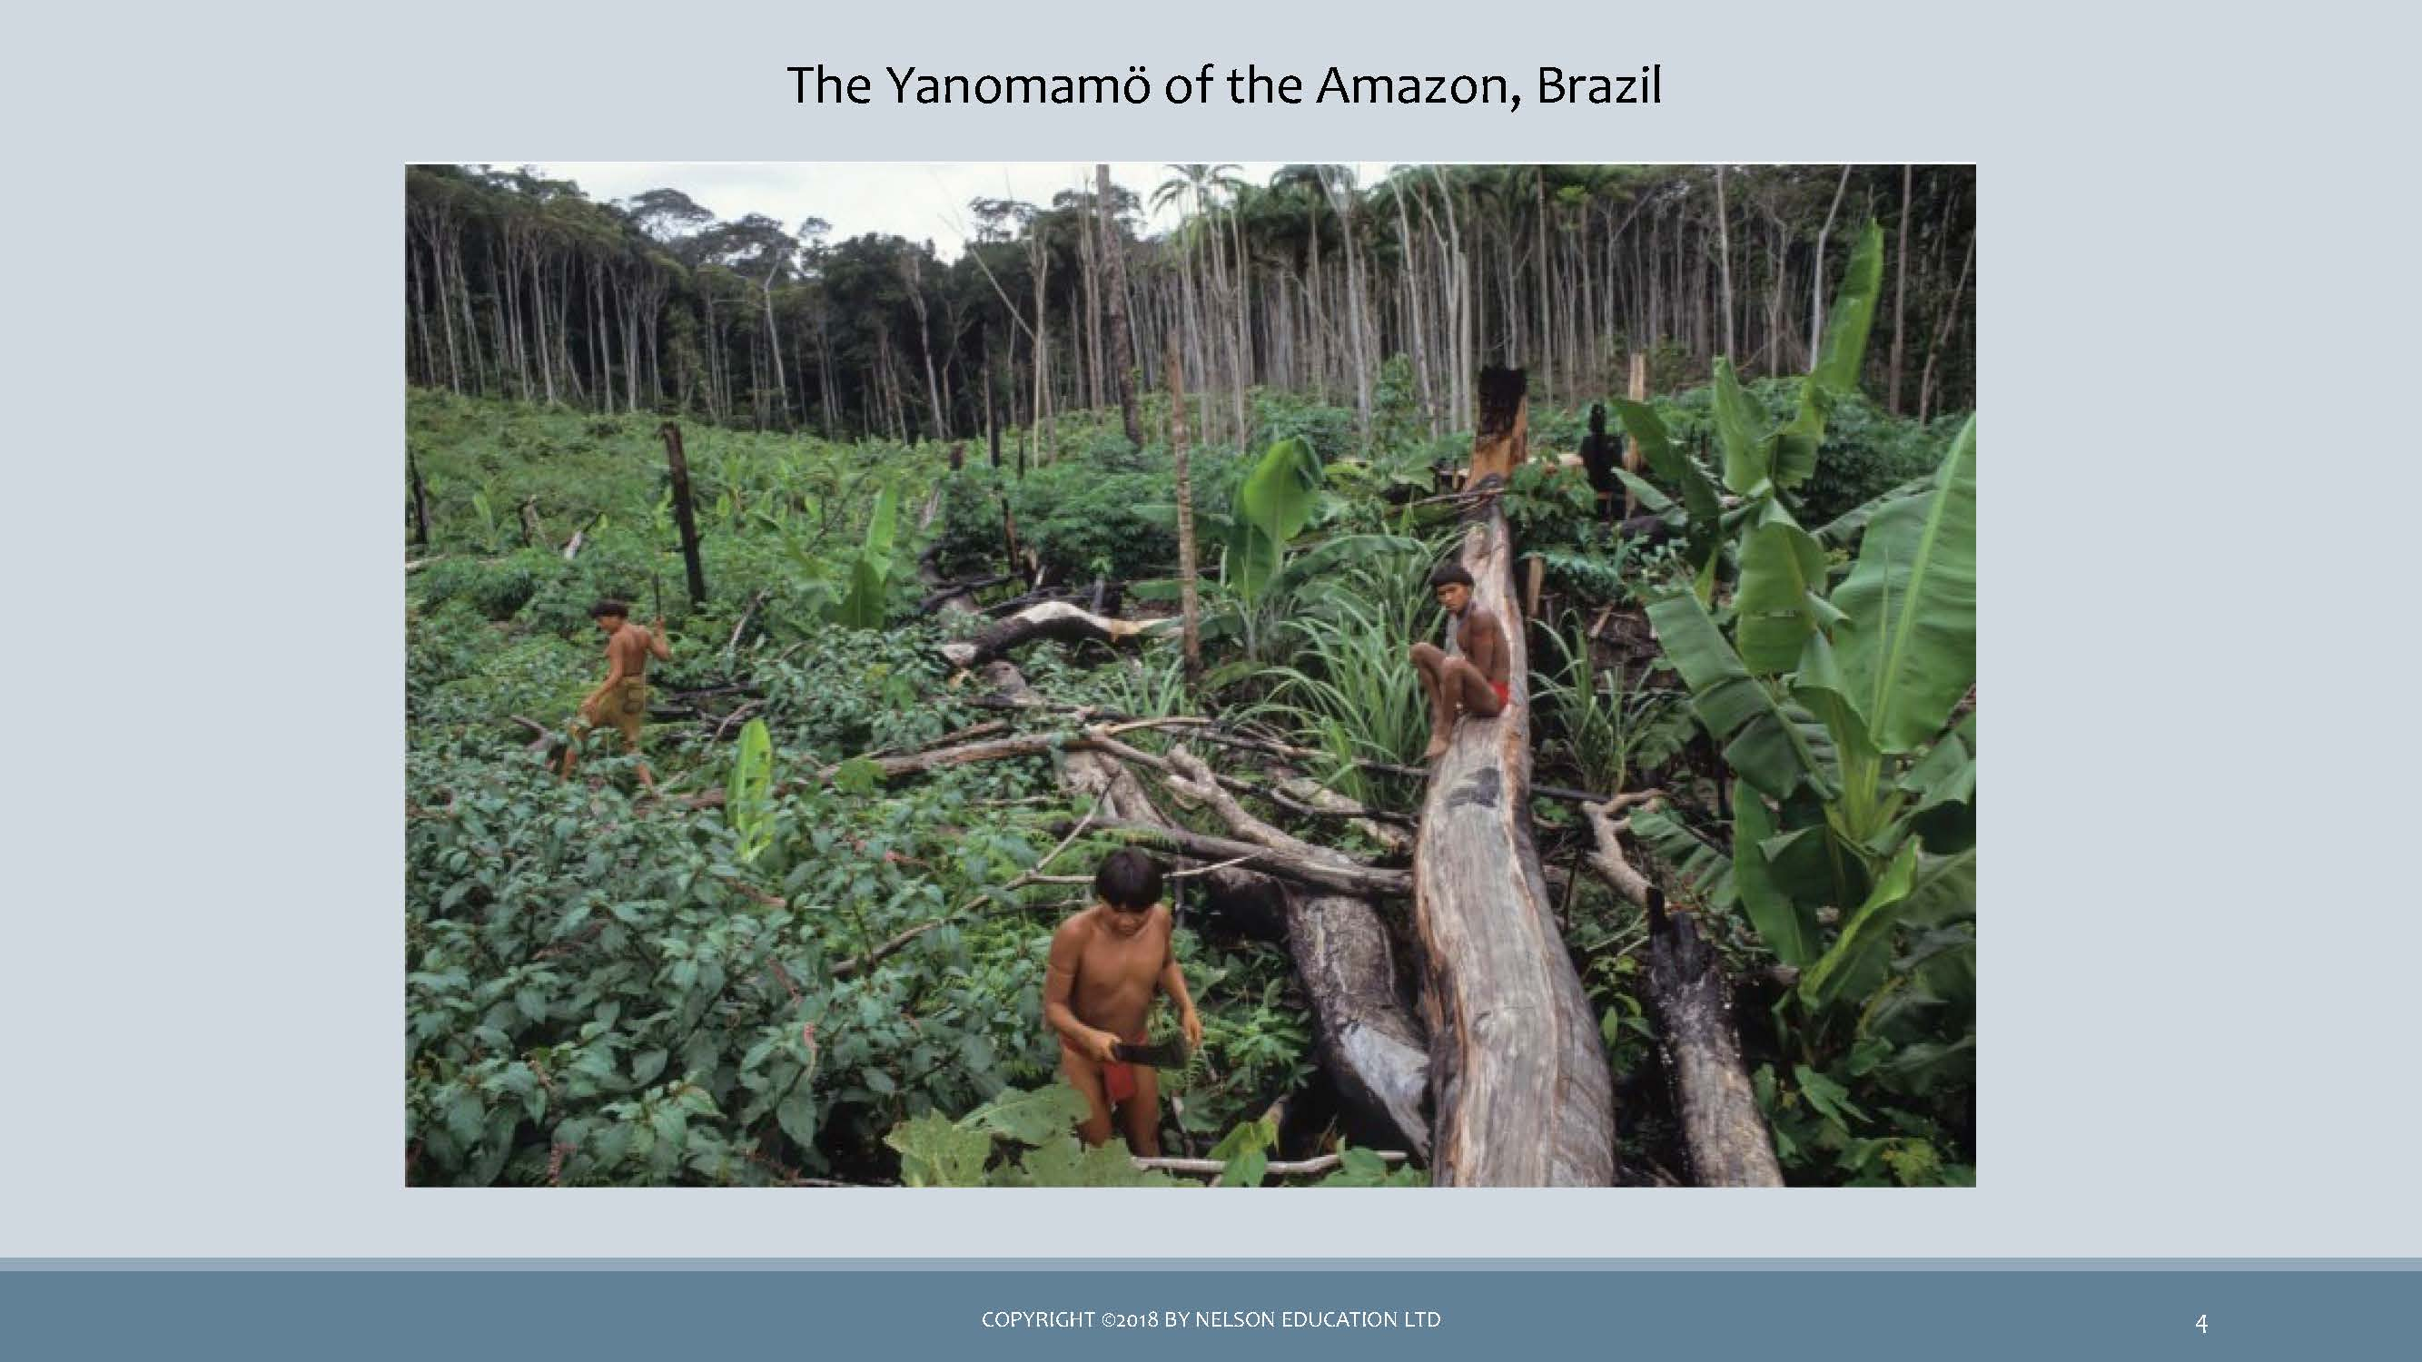 *image of the Yanomamö of the Amazon, Brazil*

* The Yanomamö practise shifting cultivation and supplement their diet with fishing and hunting.
* This way of life is rapidly disappearing due to disease, disappearance of the rainforest, and run-ins with illegal gold miners.
  + Human adaptation: also known as cultural ecology or human ecology
  + Anthropologists examine both cultural and biological adaptations
  + Many small-scale societies have adapted extremely well to their environment
  + This does not mean that they always live in total harmony with their environments. There are instances of over-farming, over-grazing, polluting waters, etc.,particularly in recent years.
  + Today, industrial practices have created many environmental tragedies such as deforestation, alteration of habitats, degradation of the soil.

Foraging Societies

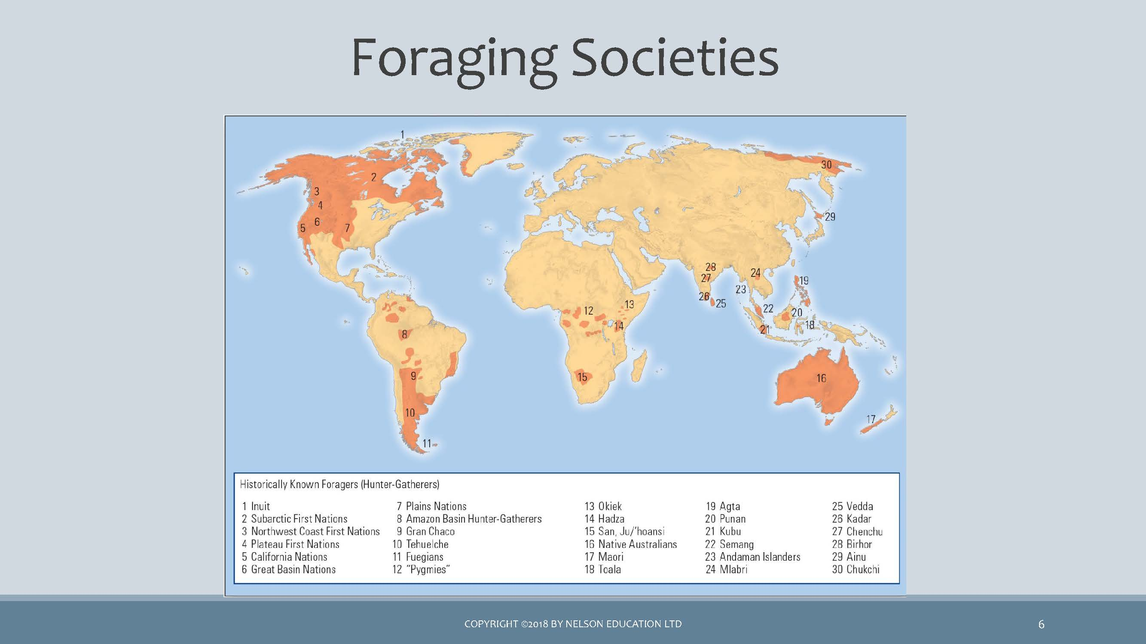 *map of Foraging Societies*

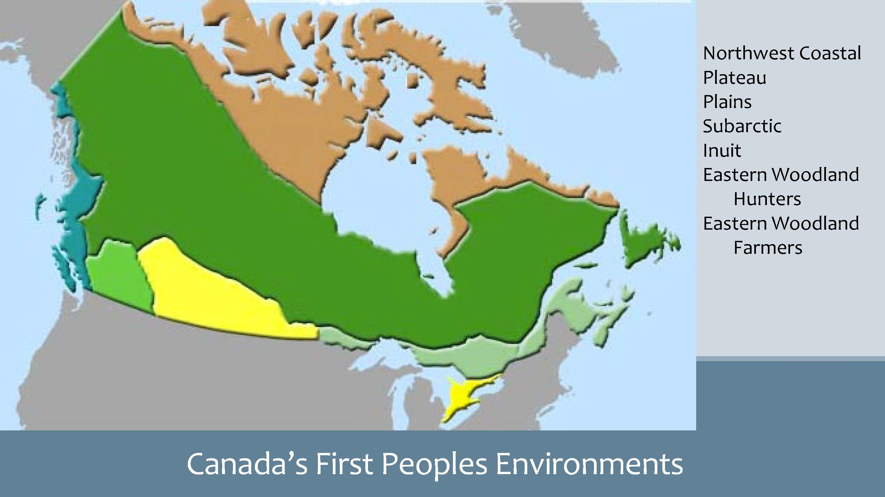 *map of Canada’s First Peoples Environment*

Wild Edibles (& medicinal plants)

 *image of wild edibles (& medicinal plants)*

 *image of forest wild berries & sea weed*

Food Collection

* HUNTERS & GATHERERS
* FORAGING
* GATHERING,FISHING,HUNTING
* OMIT P.81 (Great Basin) to p.91 top.
  + Food sources are wild plants and animals
  + All human societies were foragers, yet now very few foraging societies still exist
  + Have very low population densities (small groups); -less than half-million left
  + Are usually nomadic or semi-nomadic rather than living in one place
  + Basic social unit is the family or band
  + Contemporary food-collecting peoples occupy the remote and marginally useful areas of the earth (deserts, etc)
  + Foragers have always had contact with non-foraging peoples through trade, and have adapted to modern-day technologies (cell phone)

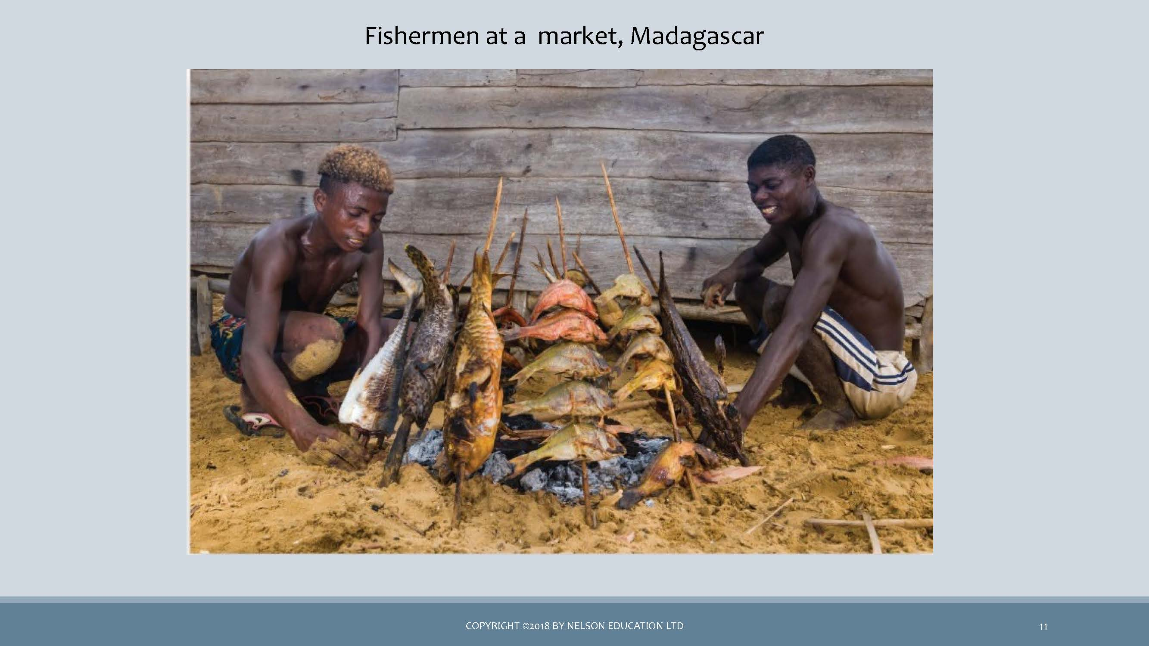 *image of fisherman at a market, Madagascar*

The !Kung of the Kalahari Region

* Inhabit area too dry to support either agriculture or the keeping of livestock
* Totally dependent on foraging for their food
* Food-gathering techniques are effective
* Selectively consume edible plants
* Survival rate and life expectancy are high
* Number of hours spent gathering food is low

### 5.1.1 🎥 Watch and Reflect - *Human Mammals, Human Hunter | Attenborough | Life of Mammals| BBC(7:09)*

* You might also want to watch:

**Why the native people of the Kalahari are struggling to stay. (7:39)**

//todo #6

The Inuit of the Arctic

* Like !Kung, the Inuit inhabit one of the least hospitable regions of the world
* Rely almost entirely on fishing and hunting of sea and land mammals
* Adapt by organizing their lives around the availability of different types of game animals and the strategies required for hunting them.

Watch

* A Seal Hunt In Nunatsiavut (2:27)
* Inuit Tradition - Hunting Seal in the Summer (6:47)
  + Group Hunting on the Spring Ice (4:57)
    - //todo #7

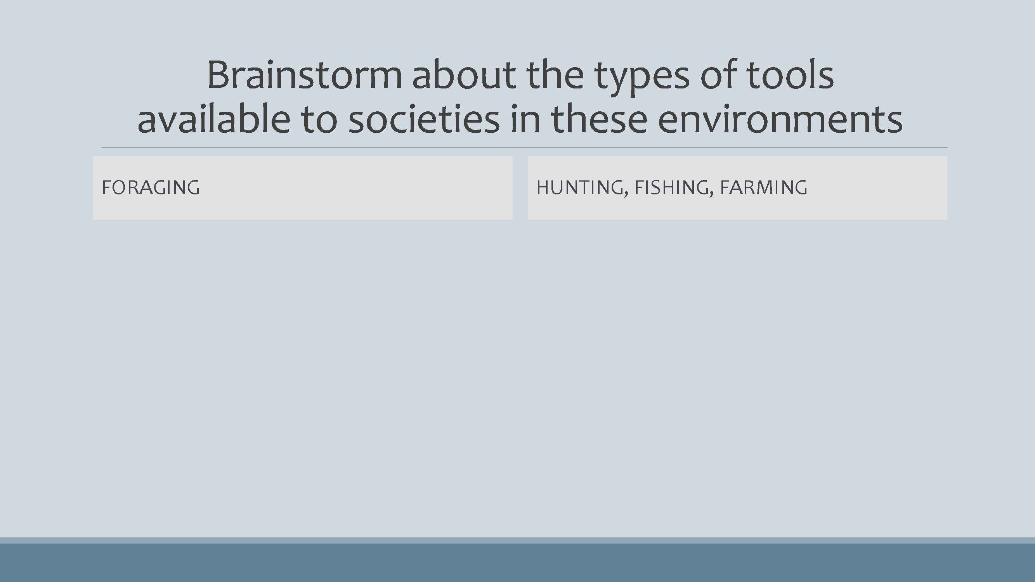 *image of a drop-down chart Brainstorm about the types of tools available to societies in these environments*

Brainstorm about the types of tools available to societies in these environments

* FORAGING
  + Baskets
  + Slingshot
  + Bow & arrow
  + Spear, harpoon
  + Digging stick, hoe
  + Nets
* HUNTING, FISHING, FARMING
  + Rifle
  + Plow
  + Commercial fishing nets
  + Combine harvesting machine

In Modern Times

* THE !KUNG, BOTSWANA BUSHMEN OF THE KALAHARI DESSERT
  + Government regulation
  + The issue / problem
  + Current status: success or failure
  + The future?
* THE YANOMAMO, BRAZIL
  + Worldwide protests
  + The issue / problem
  + Current status: success or failure
  + The future?
* Video clip:
  + Why the native people of the Kalahari are struggling to stay
* Survival website:  
  - https://www.survivalinternational.org/

indigenous rights are at the heart of our fight against climate change

* (HTTPS://US1.CAMPAIGN- ARCHIVE.COM/?U=B14580B05B832FB959C4EE444&ID=16A4F9D55 o&E=E1FF52C8AF)

battle to save people and the Amazon from destruction

* (HTTPS://MAILCHI.MP/SURVIVALINTERNATIONAL/WEVE-JUST-HEARD-SOME-AMAZING-NEWS-WED-LIKE-TO-SHARE-WITH-YOU?E=E1FF52C8AF)

Horticulture

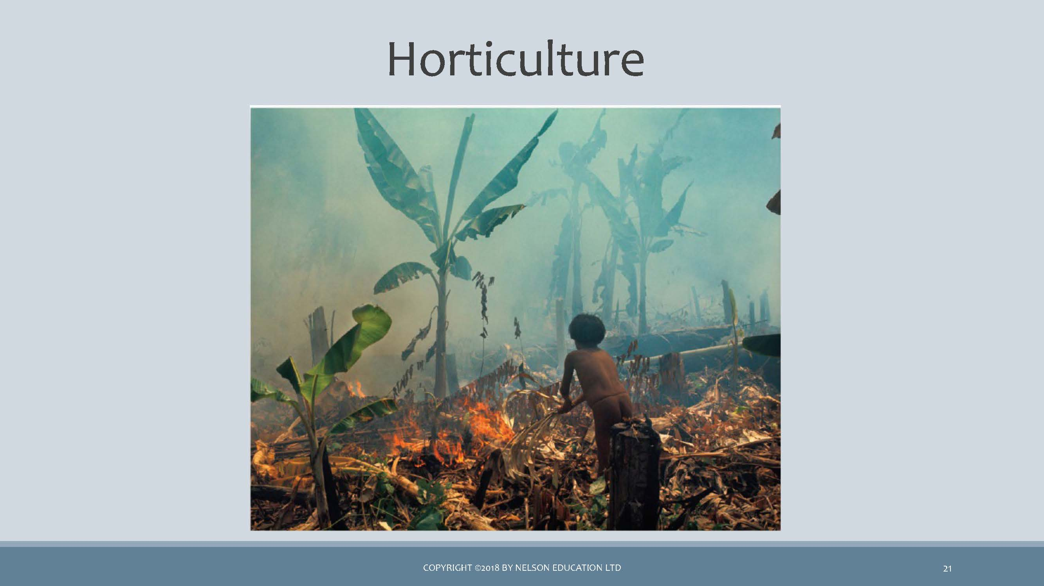 *image of plantian crop burning by a local man*

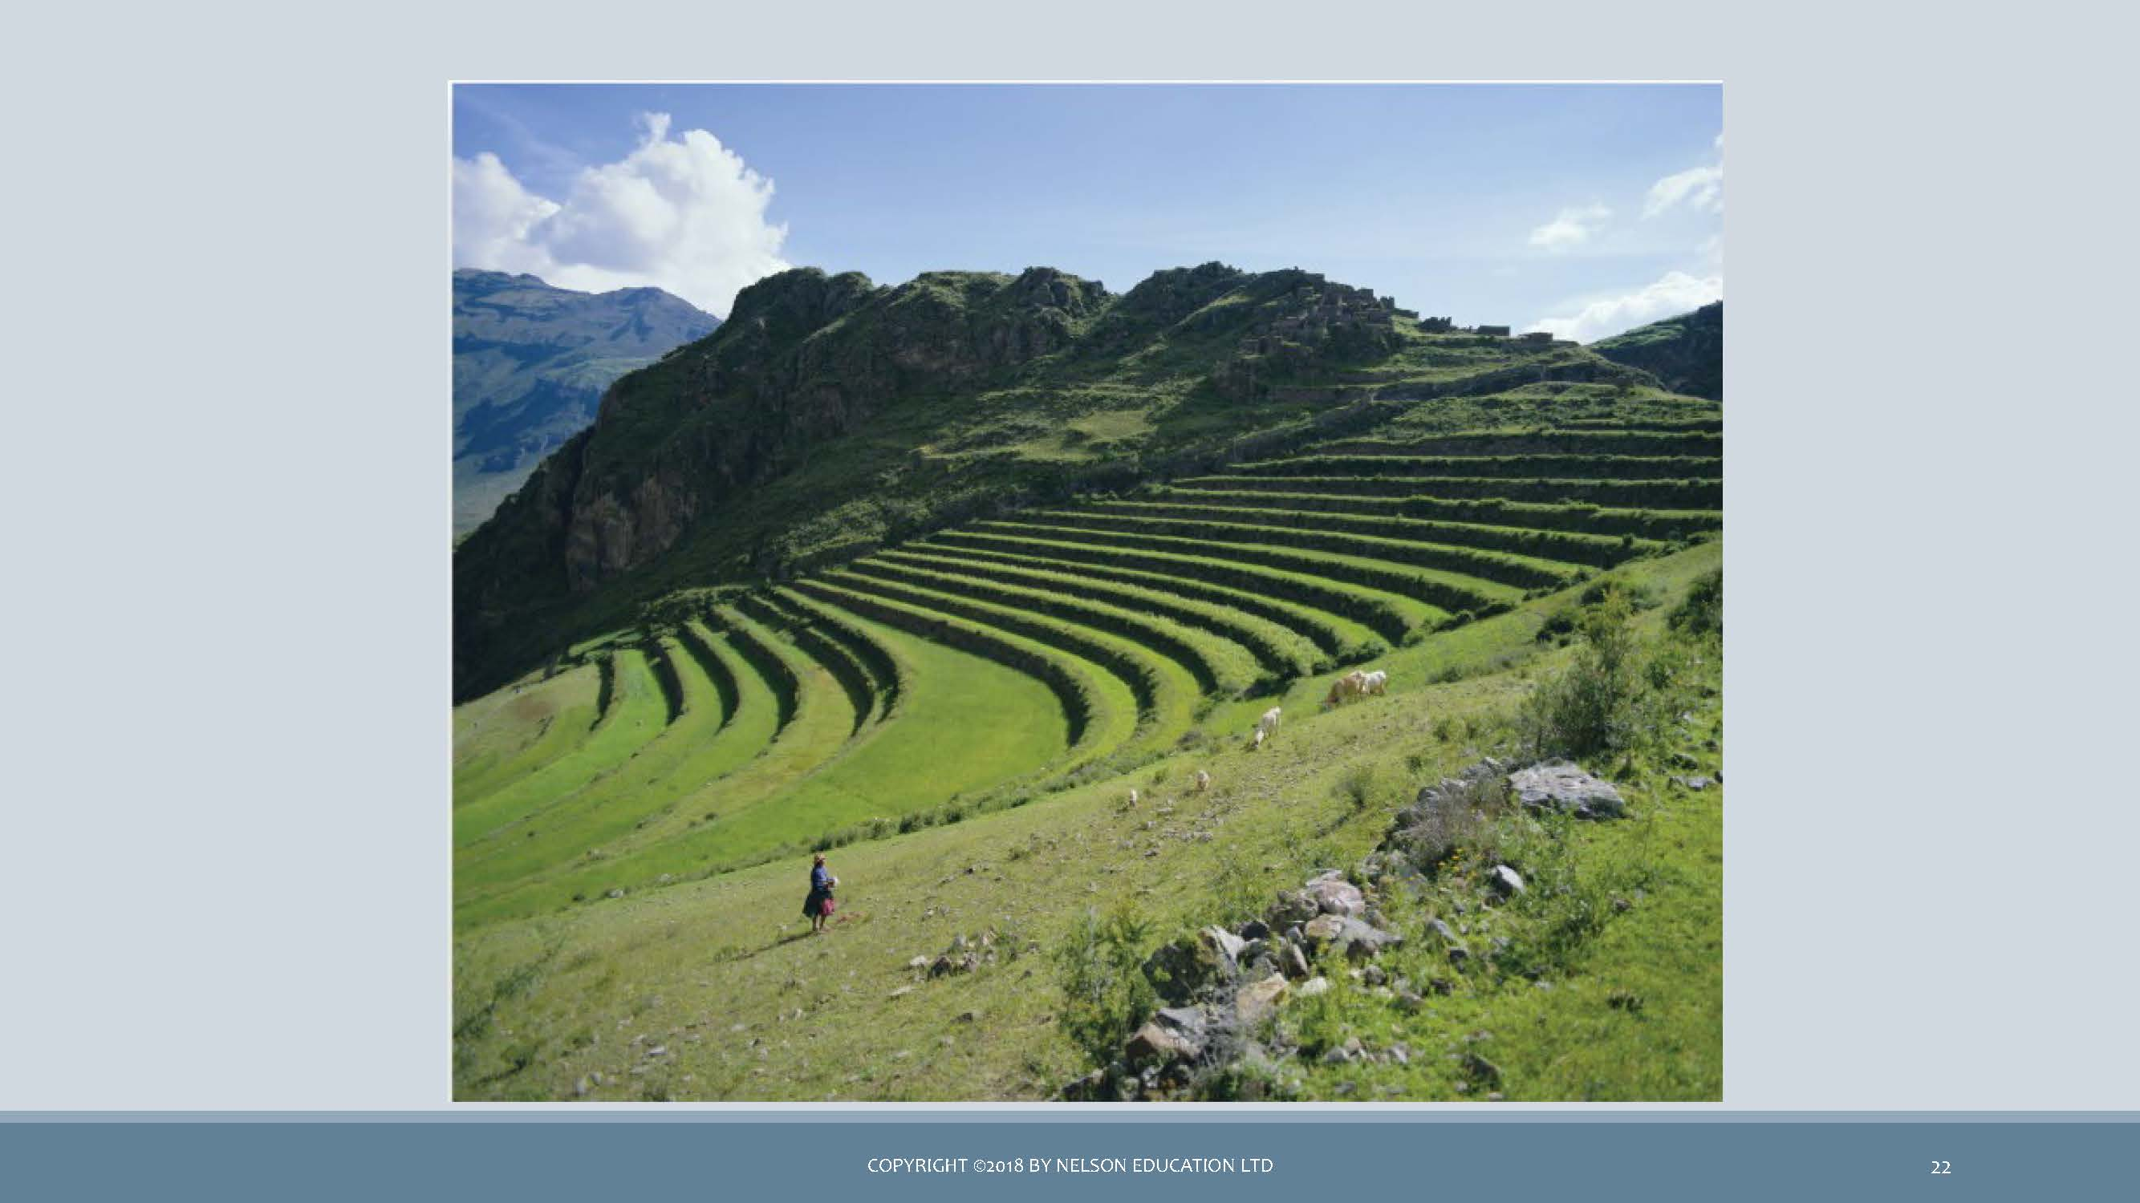 *image of step farming on a hill*

FOOD PRODUCING

* Horticulture
* Pastoralism
* Agriculture
* Ranching
* Food production is the domestication of plants and animals
* Changes resulting from food production:
  + Increased food supply to support larger populations
  + Fertility rates are higher - children are more useful economically for farmers and herders
  + Populations become more sedentary
  + Stimulated a greater division of labor
  + FOOD PRODUCING
* Note:
  + use of the horse
  + 30 varieties of corn
* Simplest type of farming that uses basic hand tools (hoe or digging stick) rather than plows or other machinery driven by animals
* Does not use irrigation or fertilizers
* Has insufficient surpluses to develop extensive market systems
* Crops can be divided into three categories
  + 1. Tree crops
    2. Seed crops: squash, beans, corn
    3. Root crops
* Many horticulturalists supplement cultivation with other food-getting strategies (e.g. hunting)
* Cannot support high densities of population (in contrast to intensive agriculture)
* Reasonably efficient form of food production

FOOD PRODUCING

* Not used much by First Nations
* Intensive cultivation
* Relies on animal power and technology rather than human power alone
* Characterized by the use of the plow, draft animals, fertilizers, irrigation, and other technological innovations
* Greater use of technology enables the support of many times more people per unit of land
* Requires a greater investment of capital and labor
* Closely associated with both higher levels of productivity and more settled communities
* A fully efficient system of food production, brought about by intensive agriculture, is a necessary, if not sufficient, condition for the rise of civilization
* Enabled development of a more complex specialization of labor

INTENSIVE AGRICULTURE

* Can support many times more people per unit of land than horticulturalism
* Must devote vast numbers of hours of hard work to prepare the land:
* peasantry
* Requires a much higher investment of capital

AGRICULTURE

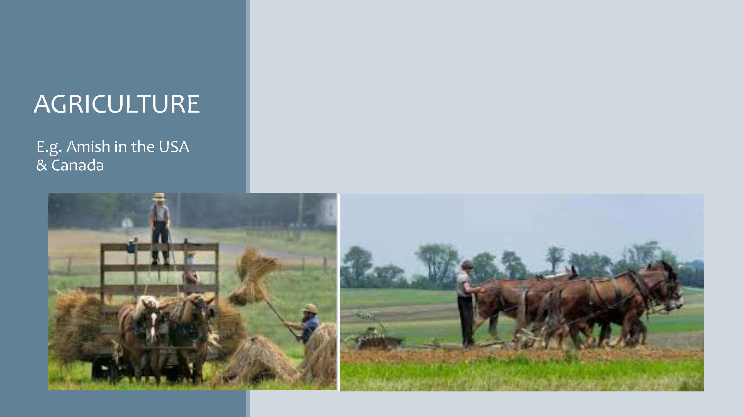 *image of Amish farmers in the USA & Canada*

INDUSTRIAL AGRICULTURE

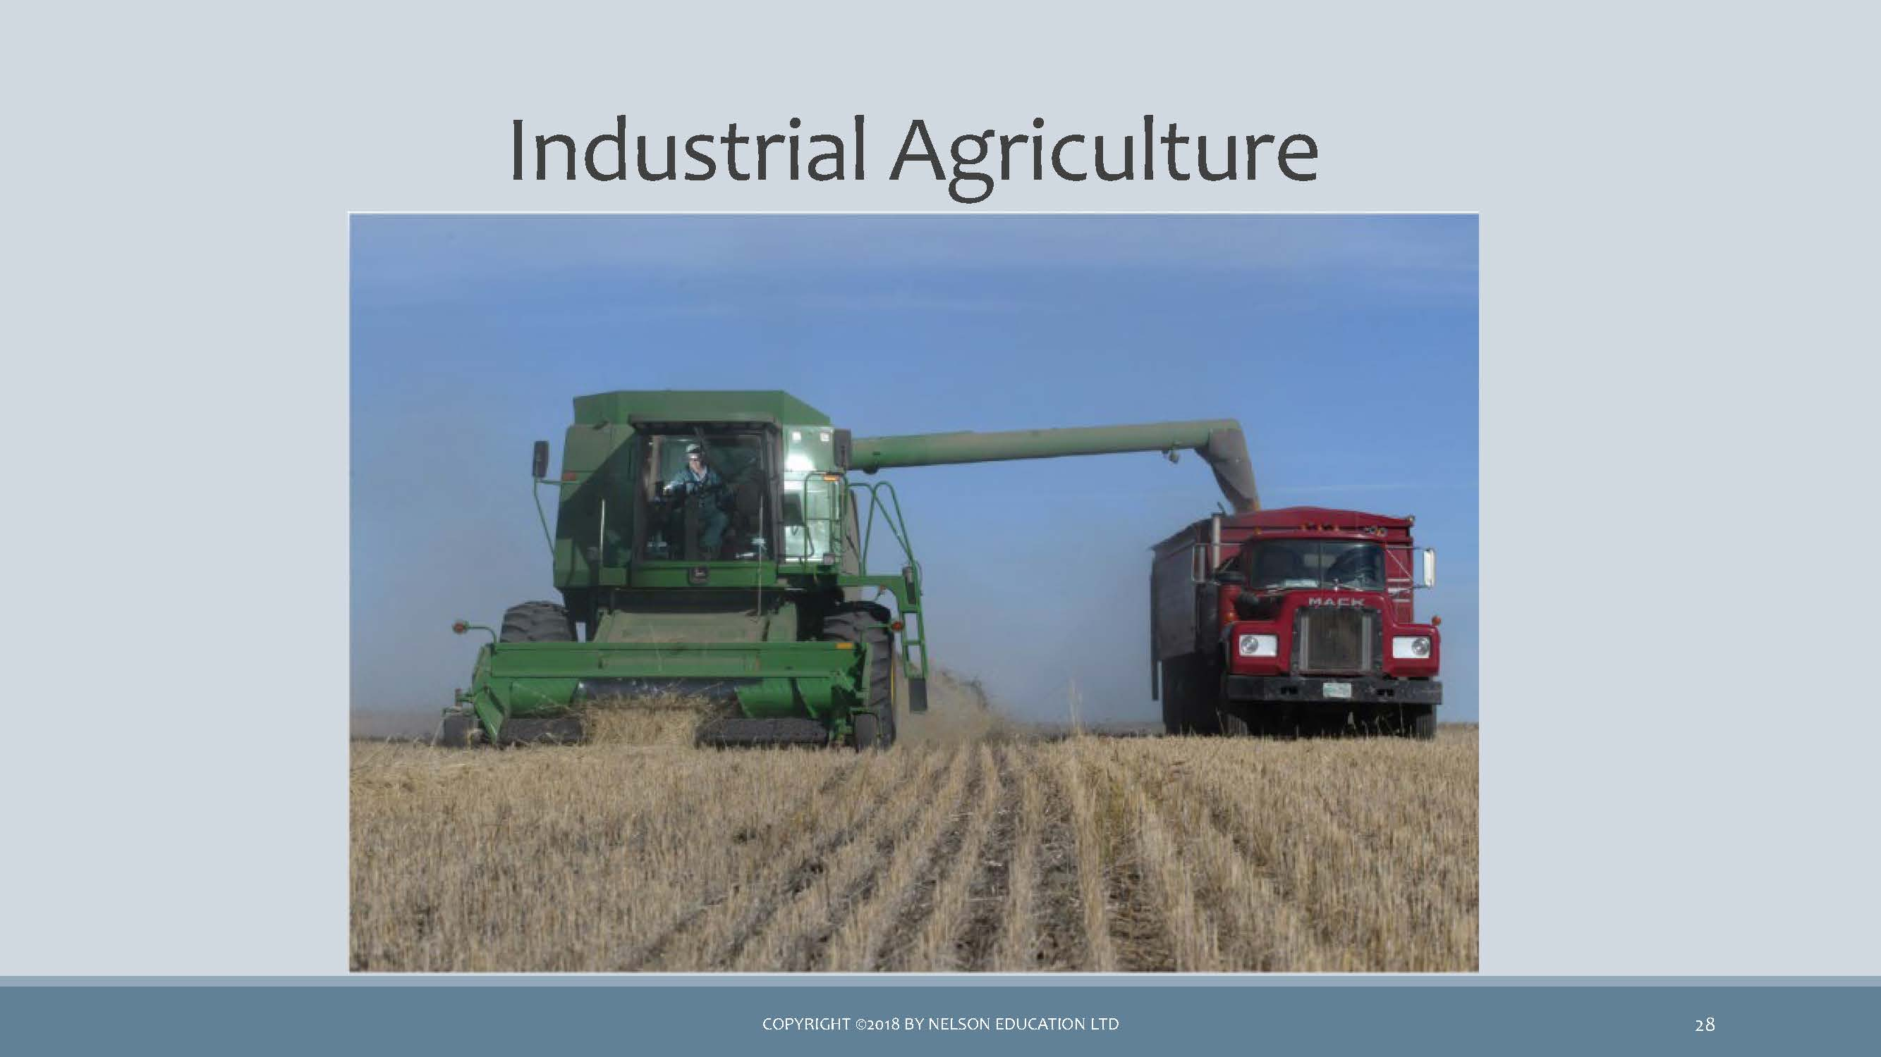 *image of industrial farm equipments being used in farming*

PASTORALISM

* E.g. Masai
* Involves the keeping of domesticated herd animals
* Found in areas of the world that cannot support agriculture
* Associated with geographic mobility

WATCH

* Masai cow herders competing for limited grazing land (0:43)
* Day in the Life of the Maasai (8:02) Watch the first 4 minutes
  + Transhumance
    - Some men move livestock seasonally to different pastures.
    - Women, children, and older men remain in permanent settlements.
  + Nomadism
    - No permanent villages
    - Whole social unit moves with livestock to new pastures.

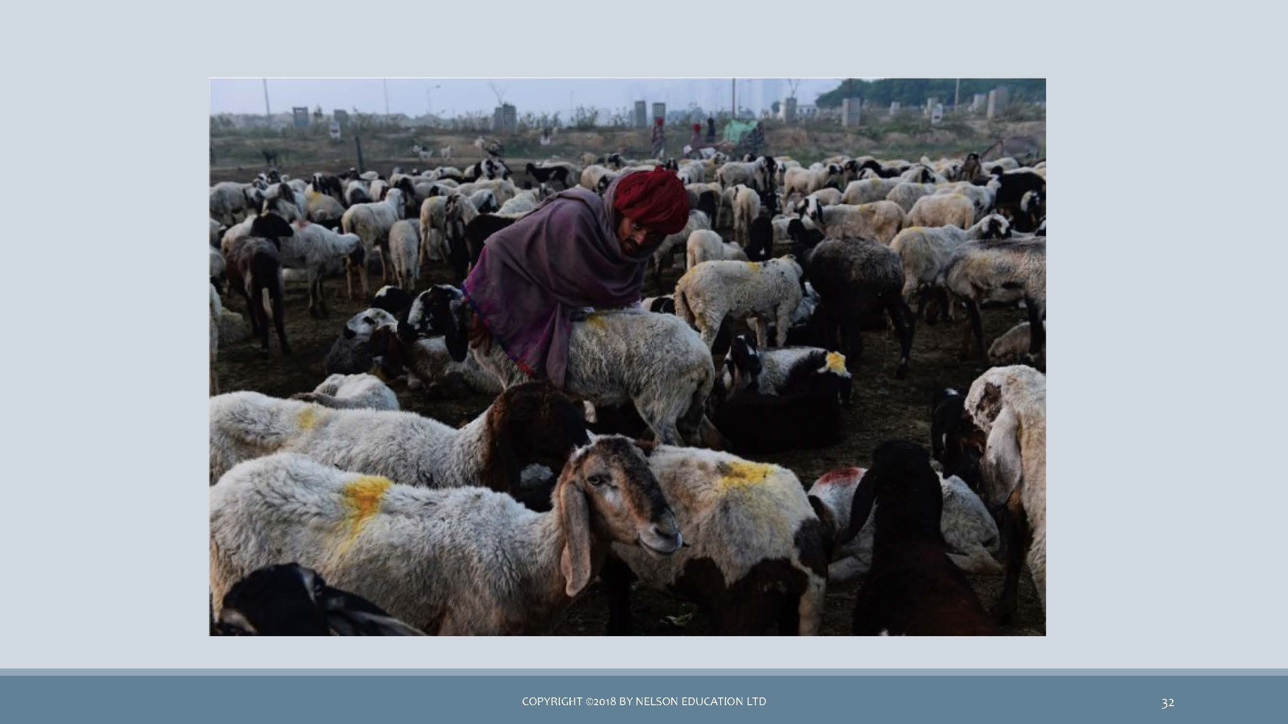 *image of local patoral farmer with his herd of goat in India*

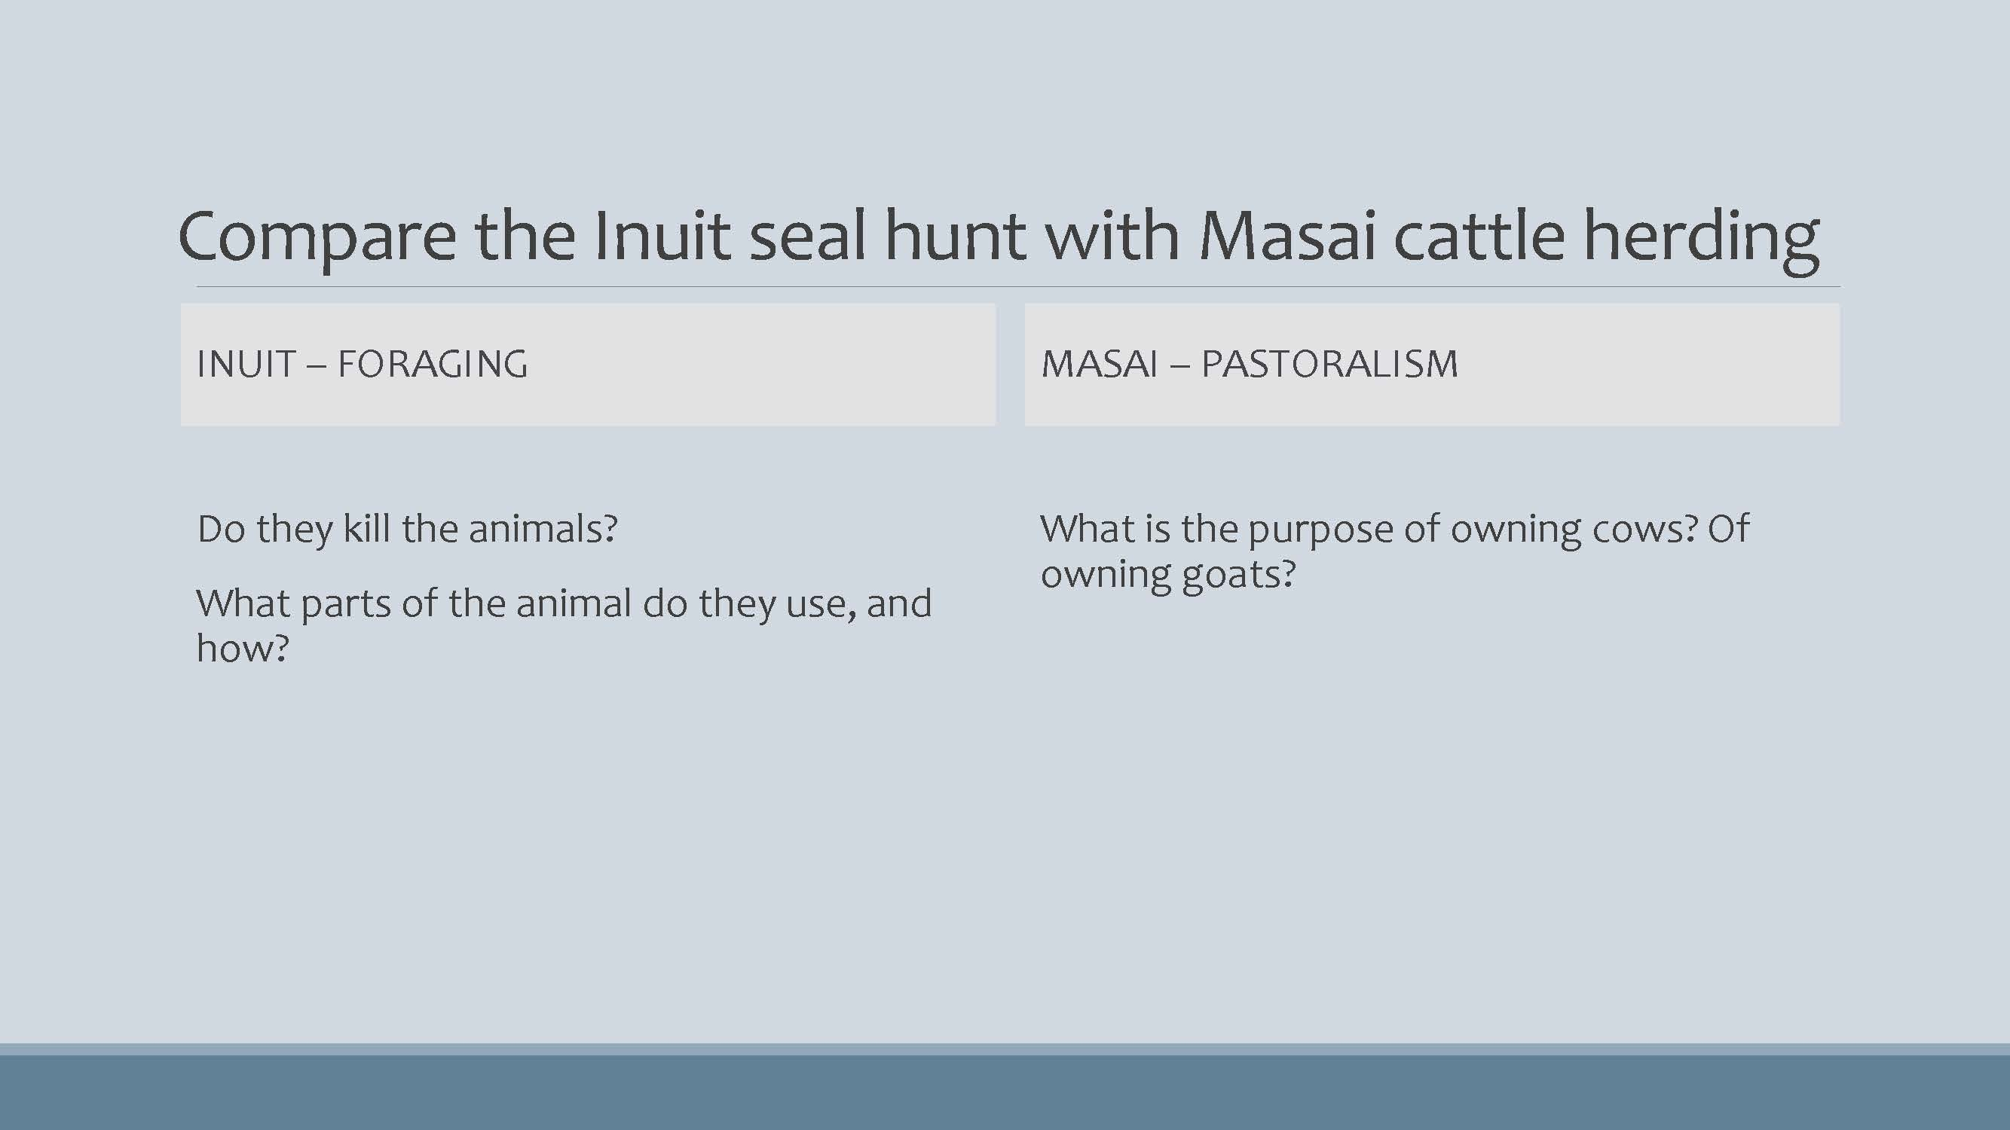 *image of a chart to Compare the Inuit seal hunt with Masai cattle herding*

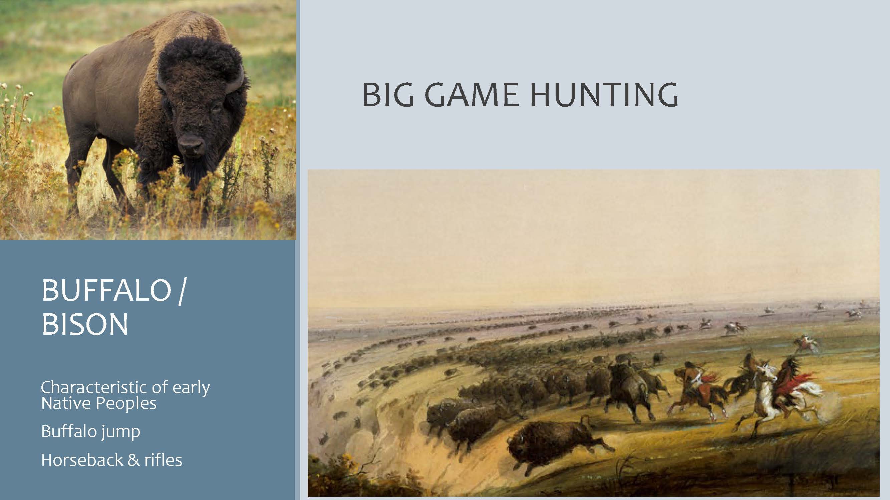 *image of a BUFFALO/BISON & BIG GAME HUNTING*

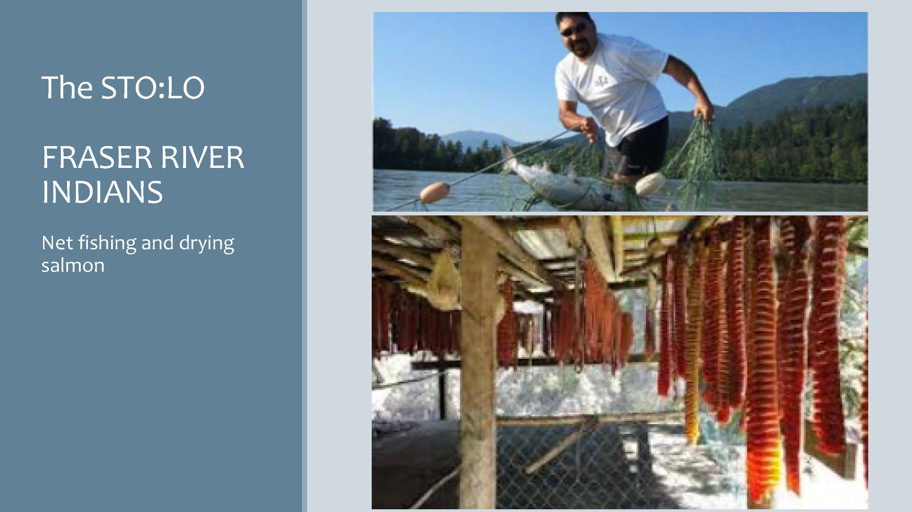 *image of a The STO:LO FRASER RIVER INDIAN net fishing and drying salmon*

Question

* The gathering of wild vegetation and the hunting of small game is the strategy of …
  + 1. horticulture
    2. pastoralism
    3. agriculture
    4. foraging
* … is a basic form of plant cultivation using simple tools and small plots of land and relying on human power. - a. pastoralism  
  - b. horticulture  
  - c. foraging  
  - d. agriculture
* Because of its reliance on animal power and technology, … differs from horticulture, and is a more intensive and efficient system. - a. hunting and gathering  
  - b. nomadism  
  - c. intensive agriculture  
  - d. pastoralism

What is a FREEGAN?

* Waste reclaimation
* Waste minimization
  + Eco-friendly transportation
* Going green
* Working less

#### 🎥 Learning Activity - Watch and Reflect

Below are three videos that will help support your understanding of the content covered throughout this unit. These videos provide some examples of the information discussed in the presentation above. Take a few moments to watch each one and be prepared to discuss them during your Learning Lab.

<:::{block2, type=‘I have not removed any content as fill in the blanks from the above presentation as the last section has already some fill in the blanks slides’> :::

<:::{block, type=‘I have not removed any content as fill in the blanks from the above presentation as the last section has already some fill in the blanks slides’> :::

## 5.2 Economics

This focus of this Topic aligns with Chapter 6 in your *Perspectives* textbook. This chapter introduces you to the three distinct phases of economic activity: ***production, exchange,*** and ***consumption.*** Production *involves transforming nature and what it produces into the material goods we need, or want.* That transformational process involves having knowledge, skills, and tools with which to make products that will be distributed and eventually consumed.

Chapter 6 also presents two interesting case studies: One on Fair Trade coffee (Guatemala); and another on Darjeeling tea (India). Your professor, Dr. Anaya, has spent 20 years going to coffee farms in Guatemala every year with the objective of having students learn about agricultural trade commodities and international development. Many students are motivated by social justice, which can be partly understood through studying Fair Trade. The objective of Fair Trade, is to achieve sustainable and equitable trade relations. It can be applied to various products, including chocolate and clothing.

The Activities below provide opportunity to learn about economic sustainability and equity through two interesting resources: One is a fair trade company (*Ten Thousand Villages*) that aims to provide equitable trade globally; and the other (*Freegan*) is website devoted to like-minded people who reject consumerism and encourage responsible local consumption.

### Topic 2 Resources

|  |  |
| --- | --- |
|  | **Note:** The resources below will help you better understand the content explored in this unit. Take some time to explore this material - it will be discussed during the Learning Lab and will play an important role in course assessments. |

### Activity Reading

|  |  |
| --- | --- |
|  | ***Reading #1***  We begin by studying economics, as it relates to Anthropology, by reading Chapter 6 in our *Perspectives* textbook. Below is a set of slides that are to be followed in conjunction with the reading - they will help focus your attention:  Click to Open  Learning Objectives   * Three modes of production * Three modes of exchange * General purpose money * Commodities * Global economic inequality   Economic Anthropology   * How humans work to obtain the material necessities such as food, clothing, and shelter * How people produce, exchange, and consume material objects * The role that immaterial things such as labor, services, and knowledge play in our livelihood * Economic anthropologists describe what people actually do and why   Modes of Production   * Domestic Production (kin-ordered)   + Foragers and small-scale farmers   + Egalitarian   + Labor organized by kinship relations   + Collective ownership of means of production   + Lower rates of social domination   + Sharing * Tributary Production   + Societies with classes of rulers and subjects   + Farmers and herders who produce for themselves but also give portion to rulers as tribute   + Communities organized by kinship   + Tribute is used by ruling class rather than exchanged   + Relationships often conflictual   + Production is controlled politically * Capitalist Production   + Began during 17th and 18th Centuries   + Private property owned by a capitalist class   + Workers sell their labor to others, are separated from the means of production   + Keep wages low in order to sell products for more than it costs to produce the products   + Generates a surplus   Modes of Production: Examples   * Fair-Trade Coffee Farmers: 21st Century Peasants   + Small-scale, semi-subsistence farmers in highland Guatemala (Maya) * Salaula in Zambia: The Informal Economy   + Global clothing recycling business   Modes of Exchange   * Reciprocity - Giving gifts create relationships   + Generalized - Exact value of the gift and time is not specified   + Balanced - Something of equal value and time period is expected (Kula ring)   + Negative - attempt to get something for nothing   + Ex: Christmas giving * Redistribution - the accumulation of goods or labor by a particular person or institution for the purpose of dispersal at a later rate   + Requires a centralized political body to coordinate and enforce   + Found in all societies   + Ex: potlatch * Markets - social institutions with prices or exchange equivalencies   + Regulated by supply and demand   + Based on transactions, often impersonal but not always   + Ex: Maine lobster markets * Money - General purpose money   + medium of exchange   + tool for storing wealth   + way to assign interchangeable values   + Increases opportunities for unequal exchang   Consumption and Global Capitalism   * Consumption - the process of buying, eating, or using a resource, food, commodity or service * Forms of behavior that connect our economic activity with the cultural symbols that give our lives meaning * Commodity - a good that is produced for sale or exchange for other goods * Objects have a “social life” (a lifespan) * Global supply chains move commodities around the world   + Ex: Darjeeling Tea production and consumers   Conclusion   * Multiple forms of economic production and exchange structure our daily lives * Community economies framework may decrease economic inequities by recognizing our interdependence * Central goal of economic anthropology is to support equality * [**Economics**](http://perspectives.americananthro.org/Chapters/Economics.pdf)   *After reviewing the slides above, read through the following chapter. This reading will help provide additional understanding of economics as it relates to the field of anthropology* *Reading #2* This resource provides you with an opportunity to explore the non-profit, Fair Trade organization called *Ten Thousand Villages.* It has become a global leader that markets handcrafted products, made by disadvantaged artisans, in more than 35 developing countries. Explore the website to learn more:   * [**Ten Thousand Villages**](https://www.tenthousandvillages.ca/) * [**Our Story: About Fair Trade**](https://www.tenthousandvillages.com/about-fair-trade/)   ***Specifically, take a look at the “Our Story: Fair Trade” page linked below. This will help you understand how fair trade works, and how it improves lives to strengthen communities:*** *Reading #3* This resource provides you with an opportunity to explore “alternative strategies for living based on limited participation in the conventional economy and minimal consumption of resources.” Once you click on the link below, take a moment to notice, and reflect upon their values – summarized on their home page as embracing “community, generosity, social concern, freedom, cooperation, and sharing in opposition to a society based on materialism, moral apathy, competition, conformity, and greed.” *How do they compare with your values?*   * [**Freegan**](https://freegan.info/) |

## 5.3 Tools and Technologies

We end this unit by looking at how tools have shaped our subsistence and our economy, and how they are intertwined with each other and many aspects of culture. Wesch provides an interesting illustration of how shoes have affected the shape of our feet. Today we might talk about how cell phones and social media affect our sleep and our relationships.

Below, you are asked to view two blogs by *Food for the Hungry*, a Christian international relief, development, and advocacy organization that seeks to “help without hurting” those it is helping. It addresses injustices and poverty of all types, through partnerships, that is, through connecting North American individuals and communities (groups and churches) with communities in the Global South. Specifically, it aims to serve the poor, the marginalized and vulnerable. It works in multiple sectors (agriculture, health, education, and more), and does so in over 20 countries globally.

## 5.4 Learning Lab

:::{block, type=‘progress’} The Learning Lab for Unit 3 will focus on an ongoing “experiment.” During this unit’s Learning Lab, students will be introduced to the “experiment.” The purpose of this experiment is to provide an opportunity to consider how your life is influenced in our modern culture. As part of this “experiment,” each student will be asked to *give something up,* in order to discover something new… :::

|  |  |
| --- | --- |
|  | **Important:** *While students will begin this experiment during Unit 3, assessment of this experience will occur at the end of Unit 5.* |

To familiarize yourself with this experiment, follow the instructions found in the link below - there are also some additional resources here to help you along:

* [**The UnThing Experiment**](https://anth101.com/challenge5/)

During this unit’s Learning Lab, your facilitator will ask you to share what you intend to give up and explain why you have chosen this particular “deprivation.” You will also be expected to share how you hope to change because of the new behaviour.

As noted above, this “experiment” involves an ongoing process. Students will be expected to submit a reflection of their experience at the end of Unit 5. To understand how you will be assessed, please review the expectations found on the [**Unit 5 Assessment**](https://learn.twu.ca/course/view.php?id=15582&section=5#tabs-tree-start) page.

|  |  |
| --- | --- |
|  | **Note:** *Students will be assessed, during Learning Lab’s, based on the* ***“Participation”*** *criteria. This criteria can be found under the* **Assignment** *tab at the top of the page - it is important to review this information prior to the Learning Lab.* |

## Assessment

### Activity: Reading

## Unit Summary

## Assessment

Although students will be graded based on their participation during the Learning Lab, *there are no other assignments that students are responsible for submitting at the end of Unit 3.*

Students are, however, responsible for submitting a reflection of their experience as part of the ***UnThing Experiment*** introduced during the Learning Lab. It is strongly recommended that students familiarize themselves with this assignment. It can be found on the “Assessment” tab in Unit 5.

Additionally, students will be tested on the content in Unit 3 during their second Unit Test. This will also occur at the end of Unit 5. :::

:::

## Checking for Learning

Before you move on to the next unit, check that you are able to:

* Identify the four modes of subsistence and describe the major activities associated with obtaining food in each system.
* Assess the ways in which subsistence systems are linked to expectations about gender roles.
* Categorize the social and economic characteristics associated with agriculture and describe the benefits and drawbacks of the agricultural subsistence system.
* Describe the characteristics of the informal economy and of fair trade (modes of production).
* Provide cultural illustrations of reciprocity, redistribution, and market exchange.
* Explain how modes of exchange, and the use of money, shape everyday life and social relations.
* Explain how intentional deprivation significantly and positively changed your values, attitudes and behaviors.
* Explain how intentional deprivation significantly and positively changed your values, attitudes and behaviors.

# 6. Understanding Social Structures of Family



Picture of a big family with many generations together

*Photo by Rajiv Perera from Unsplash*

## Overview

In Unit 4, we will study how societies around the world demonstrate remarkable variation in cultural understandings of family and marriage, and in how roles have certain rights and responsibilities, and provide status, privilege and power. Through readings and videos you will learn about different types of marriage: *who you can and may not marry, age for marriage, number of partners in marriage, and whether you even have a choice in choosing your marriage partner or in deciding where you will live or how many children you will have.*

### Topics

This unit is divided into the following topics:

1. Kinship and Descent
   * A Comparison of Kinship Terms in 4 Cultures: Croatia, China, Navajo, USA
2. Marriage and Family
   * A Comparison of 4 Types of Love: Papua New Guinea, Kenya, South India, Scotland

### Learning Outcomes

When you have completed this unit, you should be able to:

* Discuss the variation in rights and responsibilities and how these are associated with roles and status within a family and community.
* Identify the differences between kinship establish by blood and kinship established by marriage.
* Describe and illustrate the variety of human families cross-culturally; discern the different terms that define types of relationship.
* Distinguish between matrilineal, patrilineal, and bilateral kinship systems.
* Describe the variety of human families cross-culturally with examples.
* Evaluate the differences between dowry and bridewealth, as well as between different types of post-marital residence.
* Illustrate, with cultural examples, the types of relationship involving love and/or marriage.

### Activity Checklist

|  |  |
| --- | --- |
|  | Here is a checklist of learning activities you will benefit from in completing this unit. You may find it useful for planning your work. Note that all Learning Lab activities contribute towards your Participation mark for this course.   * At the bottom of the page in Topic 1, students will find some important resources. There are a number of readings and slides for you to review. Additionally, take a few moments to watch through the video. * At the bottom of the page in Topic 1, students will find some important resources. There are a number of readings and slides for you to review. Additionally, take a few moments to watch through the videos. |

|  |  |
| --- | --- |
|  | ***Note:*** *Some of these resources may be considered controversial. The intention, however, is to engage in dialogue and consider the cultural context as it relates to the subject matter of this unit.* |

The content from these videos will be discussed during this unit’s Learning Lab so come prepared for a discussion.

## Learning Lab

* The Learning Lab in Unit 4 will begin with a group discussion on the subject matter from the videos in Topic 2. Be sure to preview the videos before arriving to the Learning Lab.
* Additionally, this Learning Lab will introduce the concept of Kinship Maps. Students will watch a video during the Learning Lab that explains how to create a Kinship Map and what the purpose of one is. This will serve as important background information before you begin your assignment for Unit 4. Your Facilitator will be leading the discussion - take some time to review the information found on the “Assessment” tab for Unit 4 before you arrive.

### Assessment

|  |  |
| --- | --- |
|  | * For Unit 4, each student is expected to submit a Kinship map. The instructions and some resources are posted on the “Assessment” tab in Unit 4. It is strongly recommended that you review this page prior to attending your Learning Lab as the Facilitator will be providing some additional information. * Once you have completed your assignment, submit it for grading by uploading it to the Kinship and Descent Mapping - Activity #2 dropbox found on the bottom of the page. |

### Topic 1 Resources

* Brown, N., de González, L. T., McIlwraith, T. F., & American Anthropological Association. (2018). [*Perspectives: An Open Invitation to Cultural Anthropology.*](http://perspectives.americananthro.org/Chapters/Family_and_Marriage.pdf)
* Wesch, M. (2018). *The Art of Being Human: A Textbook for Cultural Anthropology.* New Prairie Press.
* Other online resources will be provided in the unit.

## 6.1 Kinship and Descent

Unit 4 begins by introducing the idea of kinship. In particular, we will explore an important question: *Who are the people you are related to by blood or through marriage?*

This topic covers terms and linkages for how to different ethnic groups identify and interact with their relatives.

This topic also follows Chapter 8 in your *Perspectives* textbook. In this chapter, you will be introduced to a lot of new terminology. You do not need to memorize every term in the chapter glossary, but you should be able to work with terminology and understand that the same term can mean different things in different cultures, (e.g. who is ‘mother’) and the same relationship can have different terms (e.g. a female marriage partner can be a first or third wife, or a widow or be re-married to her deceased husband’s brother).

We begin with a more in-depth study with the resources below….

### Resources

The resources below will help you better understand the content explored in this unit. Take some time to explore this material - it will be discussed during the Learning Lab and will play an important role in course assessments.

### Activity

|  |  |
| --- | --- |
|  | ***Reading #1***  To begin, take some time to read about ***Family and Marriage.*** Here you will be introduced to some important terms, and ideas, when it comes to our understanding of what “family” actually means. Below is a set of slides that are to be followed in conjunction with the reading - they will help focus your attention:  Click to Open  Learning Objectives   * Human families cross-culturally * Parental rights and responsibilities * Kinship systems * Marriage exchanges (dowry and bridewealth) * Post-marital residence   Rights, Responsibilities, Statuses and Roles in Families   * Words used to describe family members (“…” or “…”) indicate … * Status - a …-designated position a person occupies … (“…” or “…”) * Role - the set of … of a person who …   Kinship and Descent   * Kinship - culturally … between …   + Both blood (…) and marriage (…), as well … “…” * Descent - how people …   + Patrilineal - …   + Matrilineal - …   + Bilateral - …   The Formation of Descent Groups   * Patrilineal   + Most common   + …   + Daughters … * Matrilineal   + …% of …   + Inheritance through …   + Sons …   Kinship and Descent   * Lineage - … from a … * Matrilineage (descent) does not … (…) * Example: Nayar of …   + Men and women … after marriage -… as “relatives” since … matrilineage   image of black and white diagram representation of Kinship: Patrilineage  image of black and white diagram representation of Kinship: Matrilimiage  image of black and white diagram representation of Kinship: Bilateral  image of bar diagram with pictorial representation of making your own Kinship Diagram  Kinship Terminology   * The terms used … particular categories of … * Differences provide … about … * **Generation** : Some … based on generation, e.g., …, …, and their … are … * **Sex or gender** : … together because of …; e.g., …, father,…, etc. are …   + A term not … by gender in … is cousins.   Principles of Kinship Classification   * 1. Generation   2. Sex or Gender   3. Lineality versus …   4. Consanguineal versus …   5. Relative Age   6. Sex of …   7. Social …   8. … the Family   CASE STUDY   * Croatia   + Uncles: … (stric) is …, while mother’s brother (…) is … * …   + Different names for family statuses reflect different roles * Navajo   + People are “…’s clan * United States   + …, equally related …   Functions of Marriage   * 1. To … between men and women to … and …   2. To provide …   3. To create an … that supports the …, …, and … needs of …   Marriage and Family   * Nuclear family   + two … * … - at least three generations   + … or Joint family * Serial …   + marriage to a succession of spouses, one at a time * Polygamy   + … or multiple husbands     - … or Polyandry   Number of Spouses   * Monogamy   + One …   + Canada, the U.S.A., … * Polygyny   + … at a time   + …, China, Asia, …, Middle East * Polyandry   + … at a time   + Remote …   Who Can You Marry?   * Endogamy - … * Exogamy - … * Marriages have been arranged throughout … * If someone dies, then …   + Sororate and …   image of diagram for Exogamy and Endogamy  image of a couple depicting roles of romantic love and courtship  image of a woman with a child in rural Africa  Mate Selection: Who can you NOT marry?   * The Incest taboo: …   Mariage Exchanges   * Marriage Exchanges - most often given … * Dowry - gifts given … * Bridewealth - gifts given …   image of a chart for Economic Considerations of Marriage  Families, Households, and Domestic Groups   * Family - … * Household/Domestic Group - … pertaining to domestic life (may also include …)   Post-Marital Residence   * … - the family in which a person is raised * Family of procreation - … * Residence patterns   + …   + Patrilocal   + …   + …   image of a chart for Residence Patterns  image of a chart for Family Structre  ***Download the Chapter and read it as you follow along with the set of slides:***   * [**Family and Marriage**](http://perspectives.americananthro.org/Chapters/Family_and_Marriage.pdf)  Watch and Reflect We now shift our focus to learning more about kinship systems. Below is a short clip that focuses on Australian Aboriginal Kinship Systems.  As you watch the video, note that the terms of reference to family members, is common in smaller collective societies. Learn that you can have more than one mother, and discover that when using other cultural ways of identifying relationships, you could have more brothers and sisters than you thought you had. |

## 6.2 Marriage and Family

We next shift our focus to exploring cultural norms about marriage and family. Below, this topic will be studied using several videos showing uncommon practices. Some ideologies and practices are unique to small and isolated people groups (*e.g. marriage among the Na people living in the foothills of the Himalayas* (Perspectives, 2020, p. 254)). Other perspectives, however, are not universal, but are global in that they are found in societies around the world - especially nowadays due to migration transferring traditional practices into modern cities (*e.g. female genital mutilation*). Some gender practices are harmful and have been addressed by advocacy groups. Examples of these include child marriage, dowry deaths, and honor killings. Many of these practices that you will learn about, are changing due to the influence of globalization, as members of their communities are exposed to contrasting outsider practices.

We begin with our resources below:

### Topic 2 Resources

The resources below will help you better understand the content explored in this unit. Take some time to explore this material - it will be discussed during the Learning Lab and will play an important role in course assessments.

We begin with resources that tell stories of how love and relationships are seen in societal structures around the world. Most of the practices you will watch and read about may not be practiced in your country or ethno-cultural group; however, they are still practiced to a greater or lesser extent, depending on country laws and changing cultural patterns. Many of these practices are changing due to global objections and the work of advocacy groups that fight for the basic Human Rights of dignity and equality of all persons.

The first video you are to watch is about child brides in India, Yemen, Afghanistan, Nepal and Ethiopia. Very often child brides are not the only wife, they may be the first or last wife in a polygamous marriage. The next video shows you what polygamy looks like in Togo, West Africa.

The article “Love in Four Cultures” illustrates how love is experienced in Papua New Guinea, in a Masai boarding school in Kenya, in a village in South India, and in Scotland. Sometimes, marriages are not built on love, but on family agreements that require a dowry or payment to either the bride’s family or groom’s family. Some dowry practices are harmful and may even be unethical or illegal, as you will see in the last video filmed in Bangladesh and India.

*With each of these practices, it is likely that there are stark differences to how your family expresses love, and observes marriage and family customs. Note that these practices need to be understood before they are criticized.* ***Your purpose here should be to understand the practice, and why and how it is practiced.***

### Activity Learning

|  |  |
| --- | --- |
|  | **Watch and Reflect**  We begin our study of marriage practices around the world by watching a video on *The Secret World of Child Brides.* Every year, throughout the world, millions of young girls are forced into marriage. Child marriage is outlawed in many countries, and international agreements forbid the practice, yet this tradition still spans continents, language, religion, and caste.  This multi-media presentation reveals child marriage practices in India, Yemen, Afghanistan, Nepal and Ethiopia. It is important for you to be informed about the difficult experiences child brides face. Read the notes under the video to learn about how you can get involved in taking action against this practice.  Over an eight-year period, photographer Stephanie Sinclair has investigated the phenomenon of child marriage in India, Yemen, Afghanistan, Nepal and Ethiopia. Her multimedia presentation, produced in association with National Geographic, synthesizes this body of work into a call to action.  Stephanie Sinclair’s images are featured in a story on child marriage in the June 2011 issue of National Geographic magazine.  ***How to help:*** National Geographic has compiled a list of organizations that encourage families to delay marriage and give girls an opportunity to reach their full potential.  In a related post Stephanie Sinclair shares the difficult experiences child brides face. She discusses the need for their voices to be heard and the challenges she faced as a journalist who witnessed their struggles and abuse.  To learn more, follow the link:   * [**Too Young to Wed**](https://pulitzercenter.org/reporting/too-young-wed-multimedia)   This next video shifts focus to the idea of polygamy as a practice of marriage. It features a Muslim tribe in Togo, West Africa, that practices polygamy. For them, another wife means another set of hands to do the work…:   * [**Multiple Marriage**](https://video.nationalgeographic.com/video/00000144-0a40-d3cb-a96c-7b4d52580000) * Next, we explore the opposite of polygamy: polyandry. Here, we are introduced to one group of people in the Himalayas that practices the lifestyle of a woman having multiple husbands.  Reading Our focus now turns to a reading by Wesch on Love in the Four Cultures. As you read, reflect on the role of love, passion, choice, and commitment play in marriage in the four different cultures. [**Love in Four Cultures**](U4Love-Cultures.pdf) Watch and Reflect Our last resources for this section looks at an ancient marriage custom called “paying dowry.” Paying dowry is an ancient marriage custom whereby money and goods are transferred from a woman’s family to her new husband’s family. While it is officially banned in Bangladesh and India, there still is a demand for this type of economic advantage. For women, it often leads to a life of suffering, even torture and death. As you watch, Reflect on how you can take action against family violence. |

## 6.3 Learning Lab

The Learning Lab for Unit 4 will focus on expanding our understanding of some of the themes and concepts from Topics 1 and 2 in this unit. Before you arrive to this unit’s Learning Lab, be sure to review the content from each section.

In addition to these discussions, the Facilitator will also be introducing the idea of ***kinship systems*** - this component of the Learning Lab will be integral for your **Kinship and Descent Mapping - Activity #2** assignment you will be submitting at the end of Unit 4.

To learn more about kinship systems, and to help prepare you for your assignment, watch the video below - as you watch, compare your own understanding of family relationships to what you are learning about here.

## 6.4 Assessment

|  |  |
| --- | --- |
|  | For this assignment, each student will be completing and submitting a kinship diagram. To complete this assignment, follow the directions on the link below:   * [**How to Make a Kinship Diagram**](https://www.lucidchart.com/blog/make-a-kinship-diagram-online)   *You are welcome to sign up for a free account as well…*  Each student is expected to draw their own kinship diagram according to the directions outlined in the link above. Each kinship diagram should include the following:   * At least three generations   + you, your parents, and your grandparents * Both paternal sides * All siblings of both parents * All immediate relationships   + i.e marriage and children   This diagram should capture all the people you are in your direct circle of relationships. |

|  |  |
| --- | --- |
|  | **Note:** This activity may be completed in any format you like - it does, however, need to be uploaded to the dropbox below. If you choose to use *pen and paper* to complete this assignment, please take a picture and attach it as your assignment - be sure it is clear enough for the instructor to see. |

The following criteria will be used to assess your submission:

Grade | % | Assessment Criteria |  
: | :– | :- |  
 A+ | 4 | Above and beyond. Outstanding visual presentation and write-up. An A+ effort will involve several of the following: risk-taking, innovative thinking, resolving a difficult contradiction or paradox, and connecting or synthesizing ideas. |  
  A | 3.8 | Excellent work. Clear evidence that the core ideas of the topic or assignment have been understood and implemented. |  
  B | 3 | Good work, but there is not clear evidence that the core ideas of the topic or assignment have been understood, or the work could be improved through better writing, more writing, or better visuals. |  
 C+ | 2.2 | Fair work. Work is complete but it appears rushed and unpolished, or there is no evidence of understanding and some evidence of misunderstanding. |  
  D | 1 | Poor work. Work was submitted but it is incomplete, incorrect, or off the mark. |  
  F | 0 | Very poor work. Something was submitted but it is minimal, incomplete, wrong, or off the mark. |

Once you have completed your diagram, submit it for grading by selecting the **Kinship and Descent Mapping - Activity #2** assignment dropbox at the bottom of the page.

*This activity will represent 4% of your overall grade for the course - this submission will be graded by your Facilitator.*